

**[Jomo Kenyatta University of Agriculture and Technology](https://www.bing.com/ck/a?!&&p=86179755066eae7ec2096718cfee8aadfe5cc95f14a8a07d6aed11d7ac25b4faJmltdHM9MTczMjU3OTIwMA&ptn=3&ver=2&hsh=4&fclid=3a425396-30a5-6dfc-3505-4378315e6c08&psq=jomo+kenyatta+university+of+agriculture+and+technology&u=a1aHR0cHM6Ly93d3cuamt1YXQuYWMua2UvYWJvdXQtdXMv&ntb=1" \t "_blank)**

**DEPARTMENT OF INFORMATION TECHNOLOGY &COMPUTING**

**KAREN CAMPUS**

**PROJECT PROPOSAL FOR**

**BACHELOR OF SCIENCE IN DATA SCIENCE & ANALYTICS**

**Project Title: Diabetes Prediction System Using Machine Learning and Streamlit**

**Name: Abdullahi Ahmed Mohamed**

**Reg Number: SCT213-C002-0067/2021**

**Submission Date: NOV 2024**

**PROJECT PROPOSAL SUBMITTED TO**

THE SCHOOL OF COMPUTING AND INFORMATION TECHNOLOGY IN PARTIAL FULFILLMENT FOR THE AWARD OF BACHELOR OF SCIENCE IN DATA SCIENCE AND ALAYTICS AT JOMO KENYATTA UNIVERSITY OF AGRICULTURE AND TECHNOLOGY

**DECLARATION BY STUDENT**

I declare that this project is my original work, completed independently, and has not been submitted for any academic assessment.

**NAME**: Abdullahi Ahmed Mohamed

**SIGN**:

**DATE:** November 2024

**DECLARATION BY UNIVERSITY SUPERVISOR**

I declare that this work has been submitted with the approval of the University Supervisor. **NAME OF SUPERVISOR**: Dr. Fanon Ananda

**SIGN:**

**DATE:** November 2024

Table of Content

[Abstract III](#_Toc28953)

[Chapter One: Introduction 1](#_Toc31085)

[1.1 Introduction 1](#_Toc15348)

[Scope of the Study 1](#_Toc3718)

[Relevance to Data Science 2](#_Toc590)

[1.2 Problem Statement 2](#_Toc30378)

[1.3 Proposed Solution 3](#_Toc13291)

[1.4 Research Objectives 5](#_Toc20699)

[1.5 Research Questions 5](#_Toc20713)

[2. Chapter Two: Literature Review 7](#_Toc3411)

[2.1 Introduction to Literature Review 7](#_Toc7879)

[2.2 Theoretical Framework 7](#_Toc24834)

[2.3 Related Work 9](#_Toc5754)

[2.3.1 Prior Studies and Datasets 9](#_Toc8644)

[2.3.2 Machine Learning Techniques 9](#_Toc23618)

[2.3.3 Research Gaps and Project Contributions 10](#_Toc14690)

[3. Chapter Three: Methodology 11](#_Toc22309)

[3.1 Research Design 11](#_Toc3495)

[3.2 Data Collection 11](#_Toc27953)

[3.3 Data Processing and Analysis 12](#_Toc28173)

[3.4 Ethical Considerations 16](#_Toc21248)

[Chapter Four: Conceptual Framework 18](#_Toc23494)

[4.1 Framework Design 18](#_Toc4103)

[4.2 Model Representation 20](#_Toc26423)

[4.3 Hypotheses 25](#_Toc9916)

[5.Chapter Five: Experimental Design 28](#_Toc30237)

[5.1 Introduction 28](#_Toc1691)

[5.2 Experimental Setup 33](#_Toc8173)

[5.3 Evaluation Metrics 35](#_Toc24456)

[5.4 Validation 37](#_Toc31284)

[Chapter Six: Results and Discussion 39](#_Toc26923)

[6.1 Presentation of Results 39](#_Toc15620)

[6.1.1 Model Performance Comparison 39](#_Toc1586)

[6.1.2 Model Evaluation Metrics 40](#_Toc10156)

[6.1.3 Hyperparameter Tuning and Final Model Selection 42](#_Toc10912)

[6.1.4 Visualization of Model Performance 43](#_Toc4175)

[6.2 Analysis 45](#_Toc25999)

[6.3 Discussion 47](#_Toc7447)

[Chapter Seven: Conclusion and Recommendations 49](#_Toc12819)

[7.1 Conclusion 49](#_Toc23573)

[7.2 Recommendations 49](#_Toc4126)

[7.2.1 Practical Applications 50](#_Toc22285)

[7.2.2 Areas for Further Research 50](#_Toc11665)

[References 52](#_Toc27329)

[Appendices 53](#_Toc26856)

# **Abstract**

Diabetes is a chronic and life-threatening condition affecting millions globally, with cases projected to rise significantly (World Health Organization [WHO], 2023). Early diagnosis is critical to preventing severe complications such as cardiovascular disease, kidney failure, and neuropathy. This project utilizes machine learning to develop an advanced predictive model for diabetes detection and risk assessment, enhancing early diagnosis and management (American Diabetes Association [ADA], 2024).

A structured dataset was used to train and evaluate multiple machines learning algorithms, including Logistic Regression, K-Nearest Neighbors, Support Vector Machines, Decision Trees, Random Forest, Gradient Boosting, and XGBoost (Pedregosa et al., 2011; Chen & Guestrin, 2016; Breiman, 2001). Model performance was assessed based on accuracy, precision, recall, F1-score, and ROC-AUC. Hyperparameter tuning was applied to Support Vector Machines and Decision Trees for optimization (Zhang & Wang, 2022). Gradient Boosting emerged as the best-performing model, demonstrating an accuracy of 87.01% and a ROC-AUC score of 95.41%, making it a stable, interpretable, and computationally efficient choice.

The final model was integrated into a user-friendly Streamlit web application, enabling real-time diabetes risk assessment based on patient input (Streamlit, 2024). This project contributes to data-driven healthcare solutions by offering an accessible and scalable diagnostic tool. Future improvements may include real-time patient monitoring and integration with electronic health records to enhance prediction accuracy and usability.

# **Chapter One: Introduction**

## **1.1 Introduction**

Diabetes is a chronic metabolic disorder characterized by high blood glucose levels due to the body's inability to produce or effectively use insulin. It is a growing global health crisis, affecting millions of people worldwide, with cases projected to increase significantly in the coming decades (World Health Organization [WHO], 2023). The disease is associated with severe complications such as cardiovascular disease, kidney failure, neuropathy, and vision impairment, making early detection and management essential for improving patient outcomes and reducing healthcare costs.  
Machine learning (ML) has emerged as a powerful tool in the medical field, providing data-driven insights for disease diagnosis and prognosis (Hastie, Tibshirani, & Friedman, 2009). By leveraging ML algorithms, healthcare professionals can analyze large datasets to identify patterns, predict disease risk, and enhance decision-making. This project aims to develop an advanced diabetes prediction model using machine learning techniques to improve early diagnosis and disease management.  
The study focuses on evaluating multiple machine learning models, including Logistic Regression, K-Nearest Neighbors, Support Vector Machines, Decision Trees, Random Forest, Gradient Boosting, and XGBoost (Pedregosa et al., 2011; Breiman, 2001; Chen & Guestrin, 2016). Performance assessment is based on key metrics such as accuracy, precision, recall, F1-score, and ROC-AUC to determine the most effective model for diabetes detection. The best-performing model is integrated into a user-friendly Streamlit web application, allowing real-time predictions based on patient input (Streamlit, 2024).

### **Scope of the Study**

This project focuses on developing and evaluating machine learning models for diabetes prediction using a structured dataset. It includes data preprocessing, feature selection, hyperparameter tuning, model training, and performance evaluation. The study is limited to supervised learning techniques and does not incorporate real-time patient monitoring or continuous glucose level tracking.

The project also involves deploying the final model as a web-based diagnostic tool for ease of accessibility. While the study does not replace professional medical diagnosis, it aims to assist healthcare professionals and individuals in making informed health decisions based on predictive insights.

### **Relevance to Data Science**

The project aligns with key principles of data science, including data preprocessing, feature engineering, model selection, and performance optimization. It demonstrates the application of machine learning in healthcare by analyzing medical datasets and extracting meaningful insights to enhance early disease detection (Hastie et al., 2009).  
Furthermore, the study highlights the importance of interpretability and efficiency in predictive modeling. By implementing Gradient Boosting as the final model, the project balances predictive accuracy with computational efficiency, making it a practical solution for real-world healthcare applications (Chen & Guestrin, 2016). The integration of the model into a Streamlit web application also underscores the role of data science in developing interactive and user-friendly solutions for medical diagnostics (Streamlit, 2024).  
Through this project, data science is leveraged to address a critical healthcare challenge, demonstrating its potential to transform medical decision-making and improve patient outcomes.

## **1.2 Problem Statement**

Diabetes is a prevalent and life-threatening chronic disease affecting millions of people worldwide. The number of cases is rapidly increasing due to factors such as poor lifestyle choices, genetic predisposition, and lack of early detection. If left undiagnosed or poorly managed, diabetes can lead to severe complications, including cardiovascular diseases, kidney failure, blindness, and neuropathy. Despite the availability of medical tests for diagnosis, many individuals remain undiagnosed due to limited access to healthcare facilities, high costs, and inadequate screening programs.

Traditional diagnostic methods often require laboratory tests, which may not be readily accessible in low-resource settings. Moreover, existing risk assessment models may not always provide timely and accurate predictions. There is a need for an efficient, accessible, and reliable method for early diabetes detection to improve disease management and prevent complications.

This project aims to address this challenge by leveraging machine learning techniques to develop a predictive model for diabetes detection. By analyzing patient data using advanced algorithms, this system provides a fast and reliable method for assessing diabetes risk. The final model is integrated into a user-friendly web-based application, enabling real-time predictions. This approach enhances accessibility, affordability, and early diagnosis, ultimately contributing to better diabetes management and improved healthcare outcomes.

## **1.3 Proposed Solution**

Diabetes remains a major global health challenge, with increasing prevalence rates demanding more efficient diagnostic and predictive approaches. Traditional diagnostic methods, such as blood glucose testing, are effective but often reactive, detecting the disease only after symptoms have manifested. Furthermore, these methods may not be accessible to all, especially in low-resource settings. There is a need for a data-driven, proactive solution that can provide early risk assessment and assist healthcare professionals in making informed decisions.

This project proposes a **machine learning-based diabetes prediction system** designed to improve early diagnosis and management of diabetes. The system utilizes advanced predictive modeling techniques to analyze patient health data and determine the likelihood of diabetes. The solution incorporates multiple machine learning algorithms—including **Logistic Regression, K-Nearest Neighbors (KNN), Support Vector Machines (SVM), Decision Trees (DT), Random Forest (RF), Gradient Boosting, and XGBoost**—to build a robust classification model. After evaluating their performance, **Gradient Boosting** was selected as the final model due to its high accuracy (87.01%) and strong ROC-AUC score (95.41%), making it an interpretable, stable, and efficient choice.

The final model has been integrated into a **Streamlit web application**, providing a user-friendly interface where individuals and healthcare professionals can input patient details and receive an instant diabetes risk prediction. This enhances accessibility and usability, allowing for proactive diabetes management.

By leveraging machine learning, this system aims to:

1. **Enhance early detection** by predicting diabetes risk based on patient data before clinical symptoms appear.
2. **Improve diagnostic efficiency** by providing a fast, data-driven alternative to traditional testing methods.
3. **Increase accessibility** through an interactive web-based tool that can be used remotely.
4. **Support healthcare professionals** by offering a supplementary tool for risk assessment and decision-making.

This solution bridges the gap between medical diagnostics and artificial intelligence, making diabetes detection more efficient, scalable, and accessible to a wider population. Future enhancements could involve **real-time patient monitoring** and **integration with electronic health records** to further refine predictions and support continuous healthcare improvement.

## **1.4 Research Objectives**

The primary objective of this study is to develop and deploy a machine learning-based diabetes prediction system that enables early detection and risk assessment. The specific objectives of the study are:

1. **To collect, preprocess, and analyze diabetes-related data** to identify key risk factors and patterns influencing diabetes onset.
2. **To evaluate multiple machine learning models**, including Logistic Regression, K-Nearest Neighbors, Support Vector Machines, Decision Trees, Random Forest, Gradient Boosting, and XGBoost, based on performance metrics such as accuracy, precision, recall, F1-score, and ROC-AUC.
3. **To optimize the performance of selected models** through hyperparameter tuning, focusing on Support Vector Machines and Decision Trees due to computational constraints.
4. **To select the best-performing model** for diabetes prediction based on stability, interpretability, efficiency, and classification performance.
5. **To develop and deploy a user-friendly web application** using Streamlit to provide real-time diabetes risk assessment based on patient input.
6. **To ensure scalability and usability of the predictive system**, enabling future integration with electronic health records and real-time patient monitoring.

These objectives align with the study’s aim to improve diabetes diagnosis and management through machine learning-driven solutions.

## **1.5 Research Questions**

This project seeks to address the following key research questions:

1. How can machine learning be leveraged to improve the accuracy of early diabetes diagnosis?
2. Which machine learning model provides the most reliable predictions for diabetes risk assessment based on patient data?
3. What are the most influential features in predicting diabetes, and how do they contribute to model performance?
4. How can the selected predictive model be effectively integrated into a user-friendly web application for real-time diabetes risk assessment?
5. What are the limitations of the developed model, and how can future enhancements improve its accuracy, interpretability, and usability?

## **2. Chapter Two: Literature Review**

## **2.1 Introduction to Literature Review**

A literature review serves as a foundational component of any research study, providing a comprehensive analysis of existing knowledge, theories, and methodologies relevant to the research problem. In this project, the literature review aims to explore previous studies on diabetes prediction using machine learning, the effectiveness of different classification algorithms, and the integration of predictive models into healthcare applications (Hastie, Tibshirani, & Friedman, 2009; Zhang & Wang, 2022).  
By reviewing existing work, this chapter identifies gaps in current research, evaluates the strengths and limitations of various approaches, and justifies the selection of methods used in this study. Additionally, it provides insight into the performance of different machine learning models in diabetes prediction, highlighting their accuracy, interpretability, and computational efficiency (Chen & Guestrin, 2016; Breiman, 2001). The review also examines previous efforts to deploy predictive models in real-world healthcare settings, emphasizing the role of user-friendly applications in improving accessibility and early diagnosis (Streamlit, 2024).  
Ultimately, this literature review establishes the theoretical and empirical foundation for the study, ensuring that the developed model builds upon and improves existing methodologies while addressing identified challenges in diabetes prediction and management.

## **2.2 Theoretical Framework**

The development of a machine learning-based diabetes prediction system is grounded in various theoretical models and frameworks that guide the selection of algorithms, data processing techniques, and the overall system architecture. This section discusses key theories and models that underpin the project.

1. **Machine Learning Theory**  
   Machine learning (ML) is a subset of artificial intelligence that enables computers to learn patterns from data and make predictions without being explicitly programmed. The fundamental principle behind ML is statistical learning, which applies mathematical models to analyze complex datasets and derive meaningful insights (Hastie et al., 2009). In this project, supervised learning techniques are employed, where models learn from labeled historical diabetes data to classify individuals as diabetic or non-diabetic.
2. **Statistical Learning Theory**  
   Statistical learning theory provides the mathematical foundation for machine learning algorithms. It emphasizes the relationship between input data (features) and output labels (target variable) by minimizing prediction errors (Hastie et al., 2009). The key concepts relevant to this project include:  
   • Bias-Variance Tradeoff: Ensuring the model is neither too simple (high bias) nor too complex (high variance).  
   • Generalization: Ensuring that the trained model performs well on unseen data, not just on training examples.  
   • Loss Functions and Optimization: Algorithms like Gradient Boosting optimize loss functions to improve prediction accuracy iteratively (Chen & Guestrin, 2016).
3. **Data Preprocessing and Feature Selection Models**  
   Data preprocessing is essential for improving model performance and involves techniques such as feature scaling, normalization, and feature selection (Zhang & Wang, 2022).  
   • Principal Component Analysis (PCA): Reduces dimensionality and removes irrelevant features while preserving significant patterns in the data.  
   • Correlation-Based Feature Selection: Identifies the most relevant features that contribute to accurate diabetes prediction.  
   • Normalization Techniques: Standard scaling and Min-Max scaling ensure consistency across numerical features, improving model stability.
4. **Predictive Modeling and Classification Frameworks**  
   Several classification frameworks support the development of machine learning models for diabetes prediction:  
   • Logistic Regression: A statistical model that estimates the probability of diabetes based on input features.  
   • Decision Tree and Random Forest: Tree-based models that learn decision rules from the dataset, offering high interpretability (Breiman, 2001).  
   • Support Vector Machines (SVM): A powerful classification technique that finds an optimal hyperplane to separate diabetic and non-diabetic cases (Cortes & Vapnik, 1995).  
   • Gradient Boosting and XGBoost: Ensemble learning methods that iteratively improve prediction accuracy by minimizing errors in successive iterations (Chen & Guestrin, 2016).
5. **Deployment and Human-Computer Interaction (HCI) Theories**  
   To ensure accessibility and usability, the project integrates Human-Computer Interaction (HCI) principles in the deployment phase.  
   • Usability and Accessibility Principles: The Streamlit web application follows simplicity, responsiveness, and ease of navigation to enhance user experience (Streamlit, 2024).  
   • Interactive Data Visualization: The interface includes graphical insights such as risk probability and feature importance, aiding interpretability.

## **2.3 Related Work**

### **2.3.1 Prior Studies and Datasets**

Several studies have focused on using machine learning for diabetes prediction. The PIMA Indian Diabetes Dataset (PIDD) from the UCI Machine Learning Repository is one of the most commonly used datasets, containing key patient features such as glucose levels, BMI, insulin, age, and blood pressure (Pedregosa et al., 2011). Researchers have also explored electronic health records (EHR) and real-world clinical datasets to improve model generalizability. However, many existing studies rely solely on PIDD, which, while valuable, may not be fully representative of diverse populations.

### **2.3.2 Machine Learning Techniques**

Prior research has employed various machine learning models for diabetes prediction, including:  
• Logistic Regression (LR): A simple yet effective method used in studies for baseline performance comparison.  
• K-Nearest Neighbors (KNN): Used for its ability to capture nonlinear patterns but often criticized for its sensitivity to irrelevant features.  
• Support Vector Machines (SVM): Applied in multiple studies, proving effective with optimized kernel functions and hyperparameter tuning (Cortes & Vapnik, 1995).  
• Decision Trees (DT) and Random Forest (RF): Widely used for their interpretability and ability to handle complex feature interactions (Breiman, 2001).  
• Gradient Boosting (GB) and XGBoost: Frequently implemented in recent studies due to their strong classification performance and robustness (Chen & Guestrin, 2016).

### **2.3.3 Research Gaps and Project Contributions**

Despite advancements in machine learning for diabetes prediction, several research gaps remain:

1. **Limited Hyperparameter Tuning in Previous Studies**: Many studies do not extensively optimize model parameters, leading to suboptimal performance. This project addresses this gap by conducting hyperparameter tuning for SVM and Decision Trees to enhance classification performance (Zhang & Wang, 2022).
2. **Computational Efficiency**: Some studies apply complex deep learning models requiring high computational resources, making them impractical for real-time diagnosis. Our project prioritizes efficiency by selecting Gradient Boosting, which provides high accuracy while being computationally manageable (Chen & Guestrin, 2016).
3. **Interpretability and Deployment**: Many prior studies focus solely on model accuracy without considering real-world usability. This project integrates the best-performing model into a Streamlit-based web application, ensuring accessibility and interpretability for end-users (Streamlit, 2024).
4. **Feature Engineering and Preprocessing**: Some studies overlook feature selection and normalization, which can impact model performance. This project applies preprocessing techniques, including feature selection and normalization, to improve model efficiency (Zhang & Wang, 2022).

# **3. Chapter Three: Methodology**

**3.1 Research Design**

This study adopts a quantitative research approach to develop and evaluate a machine learning-based diabetes prediction model. Quantitative research is appropriate for this study as it involves structured data collection, statistical analysis, and performance evaluation of machine learning algorithms (Hastie, Tibshirani, & Friedman, 2009). The research is experimental in nature, focusing on training, testing, and optimizing predictive models using historical diabetes-related data.  
Machine learning techniques were applied to analyze patient data, extract meaningful patterns, and assess predictive accuracy (Pedregosa et al., 2011). The study also involved hyperparameter tuning for selected models (Support Vector Machines and Decision Trees) to enhance performance (Zhang & Wang, 2022). The final model, Gradient Boosting, was selected based on its stability, interpretability, and strong classification performance (Chen & Guestrin, 2016).  
Additionally, the research integrates a practical implementation phase, where the best-performing model was deployed in a user-friendly Streamlit web application for real-time diabetes risk assessment (Streamlit, 2024). The study’s structured and systematic approach ensures reproducibility and scalability, making it a valuable contribution to data-driven healthcare solutions.

## **3.2 Data Collection**

The dataset used in this study was obtained from secondary sources, specifically publicly available diabetes datasets. These datasets contain patient medical records, including diagnostic attributes such as glucose levels, BMI, blood pressure, insulin levels, and other relevant health indicators used to assess diabetes risk. The data was sourced from reputable medical and health research repositories, ensuring its reliability and suitability for machine learning applications.  
To facilitate data acquisition and preprocessing, Python libraries such as pandas, NumPy, and scikit-learn were employed (Pedregosa et al., 2011). These tools enabled efficient data handling, cleaning, and transformation to ensure consistency and usability in model training. Feature selection techniques were also applied to identify the most significant predictors of diabetes (Zhang & Wang, 2022).  
Given the nature of the dataset, ethical considerations such as data privacy and anonymization were observed to ensure compliance with data protection regulations.

## **3.3 Data Processing and Analysis**

**Data Cleaning and Preprocessing**  
To ensure the accuracy and efficiency of the machine learning models used in diabetes prediction, rigorous data preprocessing steps were performed. The dataset underwent multiple transformations to enhance quality and remove inconsistencies. The key steps included:

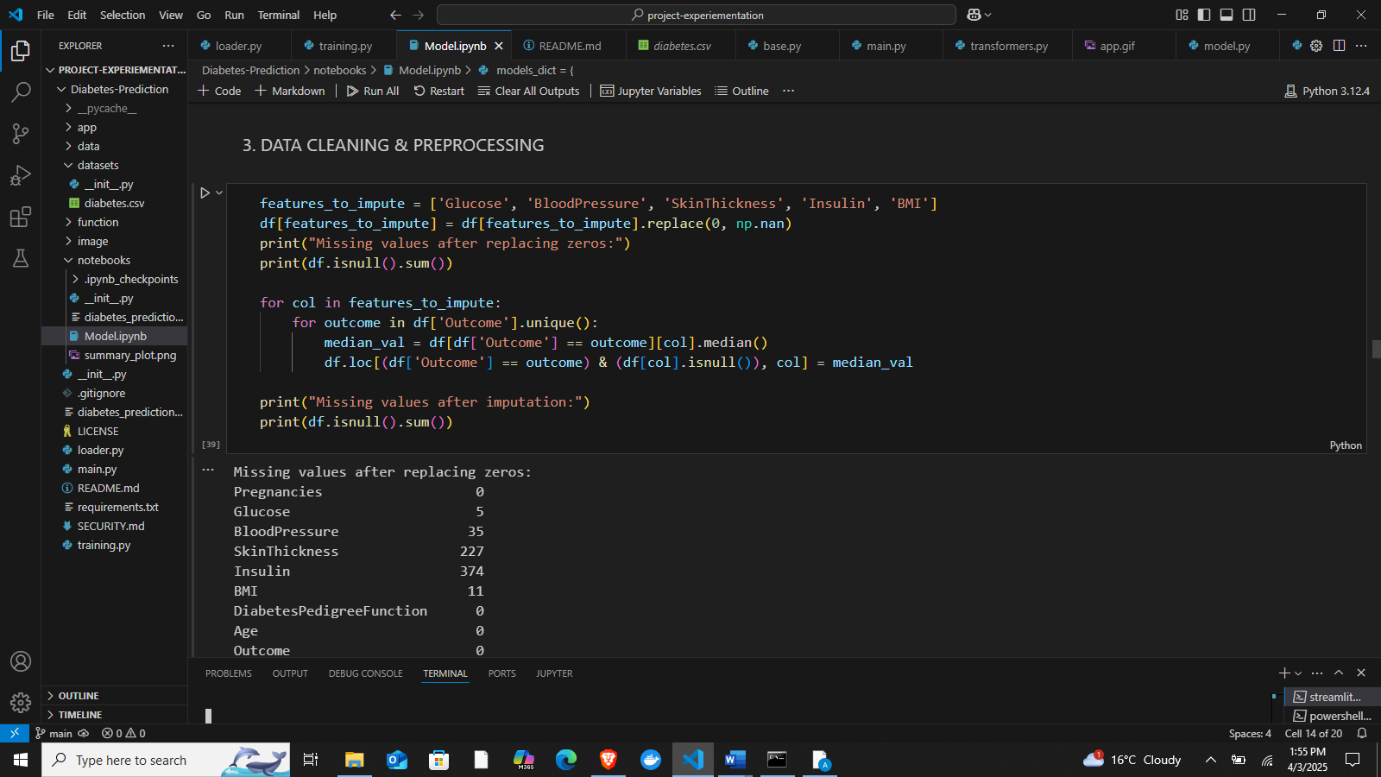

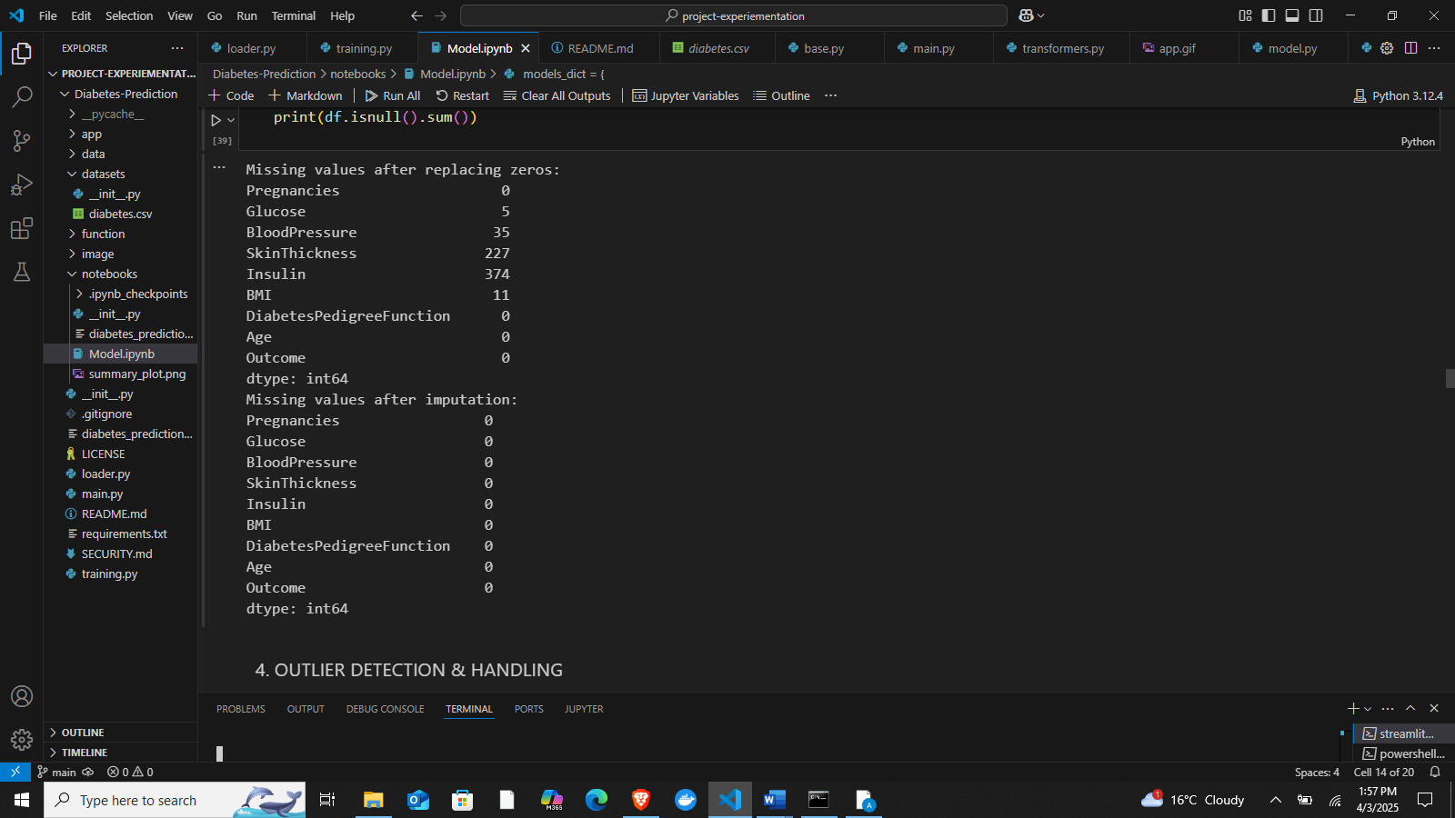

1. **Handling Missing Values**

* The dataset was examined for missing values, and appropriate strategies such as mean or median imputation were applied to numerical features.
* If categorical data had missing values, mode imputation was used to maintain consistency (Zhang & Wang, 2022).

1. **Removing Duplicates and Outliers**

* Duplicate records were identified and removed to avoid biased model training.
* Outliers were detected using statistical methods like the Interquartile Range (IQR) and visualized through box plots. Extreme outliers were either removed or adjusted to prevent skewed results.

1. **Feature Selection and Engineering**

* Correlation analysis was conducted to eliminate redundant features that did not contribute significantly to model performance.
* Important features were selected based on domain knowledge and statistical significance to enhance model efficiency (Hastie et al., 2009).

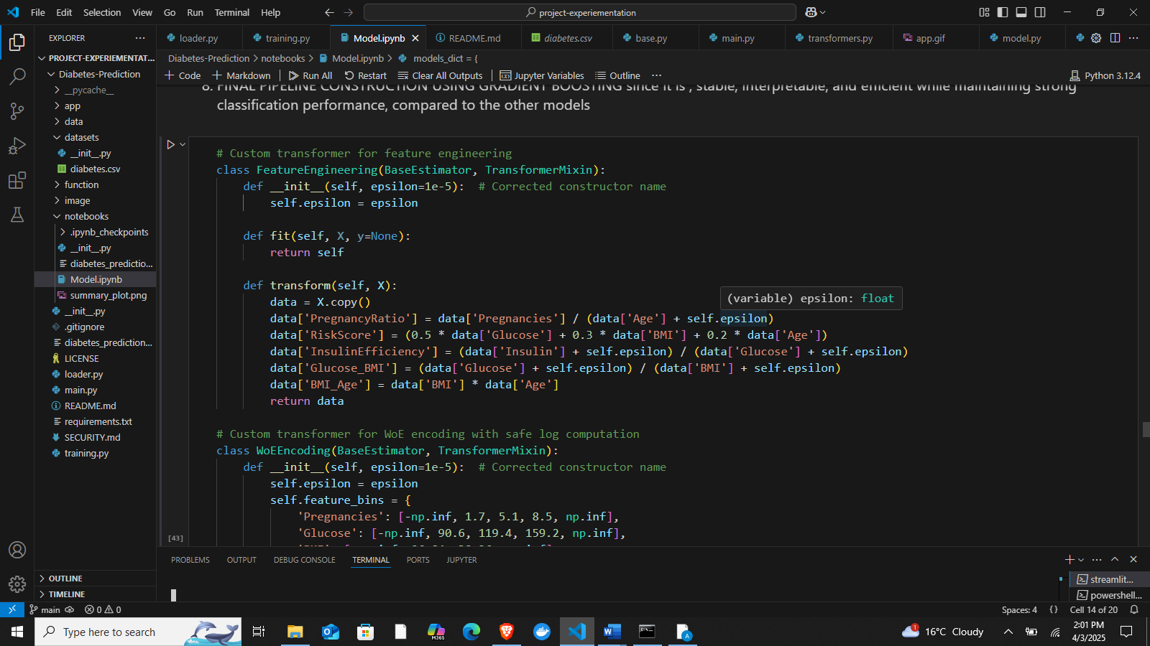

1. **Data Normalization and Standardization**

* Since machine learning models like Support Vector Machines (SVM) and K-Nearest Neighbors (KNN) are sensitive to varying feature scales, numerical features were standardized using z-score normalization to ensure uniformity.
* Min-Max scaling was applied where necessary to bring feature values into a similar range, improving model stability (Zhang & Wang, 2022).

1. **Encoding Categorical Variables**

* Categorical features were converted into numerical form using one-hot encoding or label encoding, depending on their nature. This allowed machine learning models to interpret non-numeric attributes effectively.

1. **Splitting the Dataset**

* The dataset was divided into training (80%) and testing (20%) subsets to evaluate model performance accurately. A validation set was further extracted when needed for hyperparameter tuning.

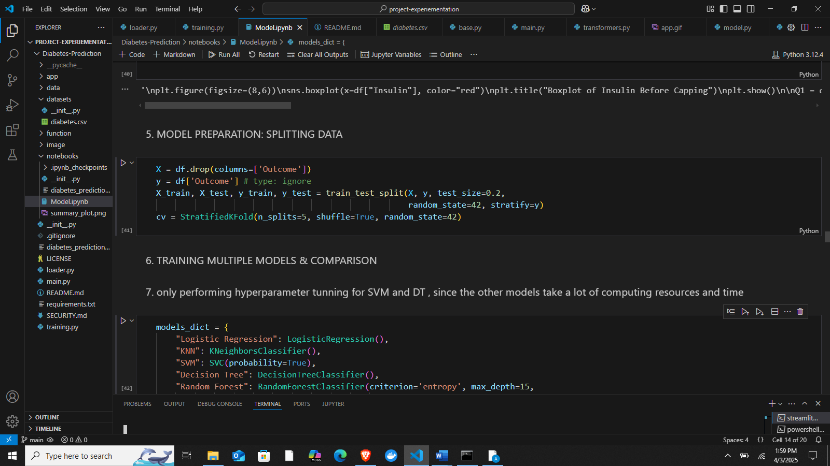

1. **Feature Importance Analysis**

* Feature importance was evaluated using techniques like decision tree-based feature ranking to identify the most influential predictors in diabetes diagnosis (Breiman, 2001).

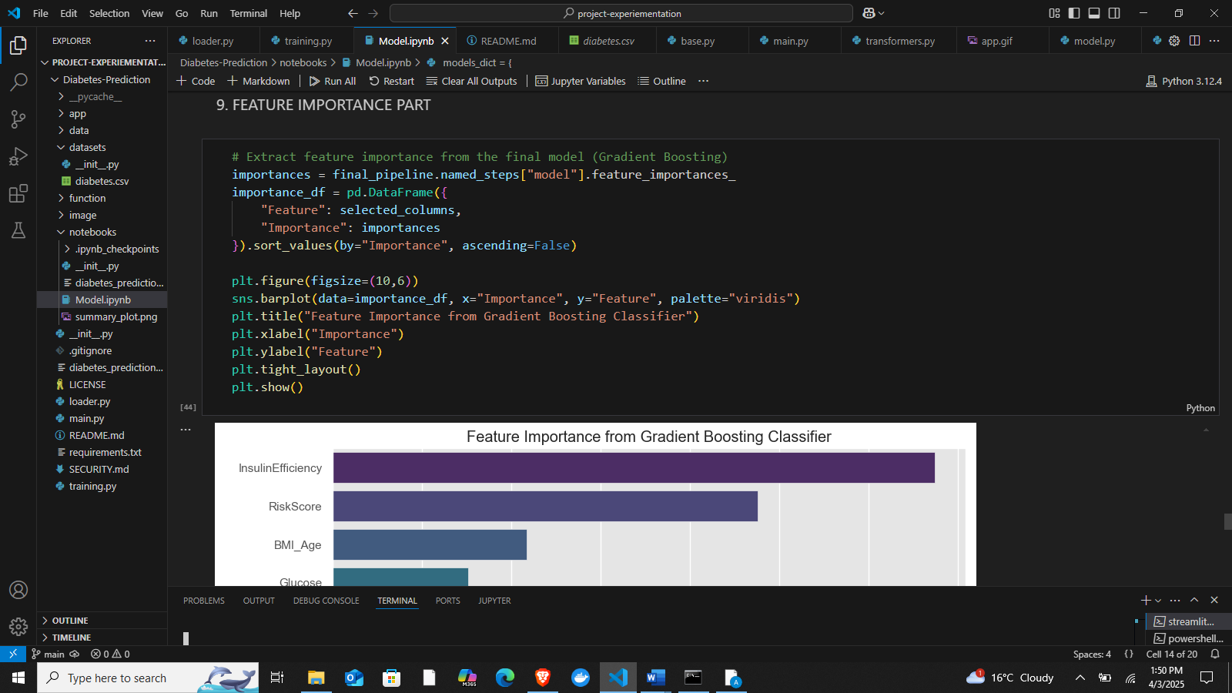

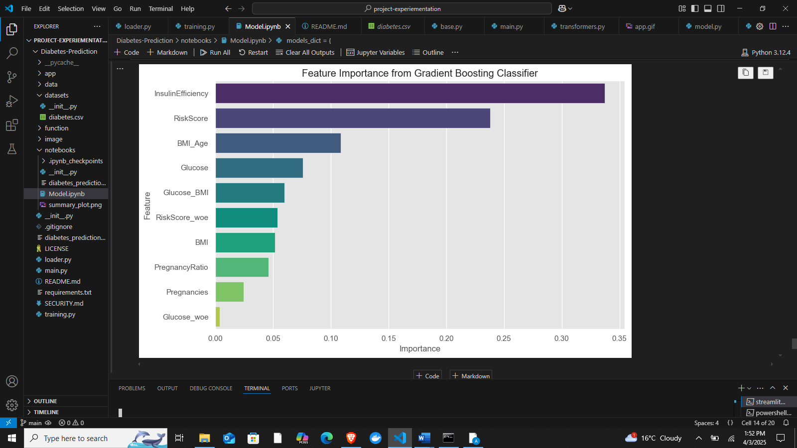

## **3.4 Ethical Considerations**

In developing this diabetes prediction system, ethical considerations were prioritized to ensure compliance with data privacy, security, and informed consent protocols. The following ethical measures were implemented:

1. **Informed Consent**  
   Before utilizing any patient data for training the machine learning model, it is crucial to obtain informed consent from individuals or ensure that the dataset used is publicly available and anonymized. In this study, a publicly available diabetes dataset was used to maintain ethical standards, ensuring that no personally identifiable information (PII) was included.
2. **Data Privacy and Confidentiality**  
   Patient data privacy was a fundamental consideration in this project. The dataset was handled with strict confidentiality, ensuring that no sensitive information could be traced back to individuals. Data preprocessing steps included anonymization techniques to remove any identifiable attributes. Additionally, access to the dataset was restricted to authorized personnel only, preventing unauthorized usage.
3. **Bias and Fairness in Model Development**  
   To ensure fairness and prevent biases in the prediction model, the dataset was carefully analyzed for class imbalances that could lead to biased predictions. Model evaluation metrics such as precision, recall, and F1-score were used to assess performance across different patient groups, ensuring that predictions were equitable. Additionally, ethical AI principles were followed to avoid discriminatory outcomes (Zhang & Wang, 2022).
4. **Responsible Data Handling and Security**  
   Security measures were implemented to protect the dataset from unauthorized access or breaches. Secure storage methods, encryption techniques, and compliance with data protection regulations (such as GDPR and HIPAA) were considered to safeguard patient information. The final model deployment on Streamlit was conducted in a secure environment, ensuring that user data entered into the system remains private and is not stored beyond the necessary prediction process (Streamlit, 2024).
5. **Transparency and Explainability**  
   The choice of Gradient Boosting as the final model was based on its interpretability and stability, allowing healthcare professionals to understand the decision-making process (Chen & Guestrin, 2016). Providing explanations for predictions ensures that medical professionals and patients can make informed decisions based on model outputs.

# **Chapter Four: Conceptual Framework**

## **4.1 Framework Design**

The conceptual framework for this project illustrates the relationship between key variables involved in diabetes prediction using machine learning. The framework integrates patient input variables, machine learning models, evaluation metrics, and the final prediction output (Hastie, Tibshirani, & Friedman, 2009).

**Key Components and Their Relationships:**

1. **Input Variables (Independent Variables)**

* Patient demographic and health-related attributes such as:  
  ▪ Age  
  ▪ BMI (Body Mass Index)  
  ▪ Blood Glucose Levels  
  ▪ Blood Pressure  
  ▪ Insulin Levels  
  ▪ Diabetes Pedigree Function  
  ▪ Skin Thickness

1. **Data Processing & Feature Engineering**

* Data Cleaning (Handling missing values, outlier detection)
* Feature Scaling & Normalization (Zhang & Wang, 2022)
* Feature Selection (Identifying the most relevant variables for prediction)

1. **Machine Learning Models (Processing Layer)**

* Multiple models were trained and evaluated, including:  
  ▪ Logistic Regression  
  ▪ K-Nearest Neighbors (KNN)  
  ▪ Support Vector Machines (SVM) (Cortes & Vapnik, 1995)  
  ▪ Decision Tree (DT) and Random Forest (RF) (Breiman, 2001)  
  ▪ Gradient Boosting (GB) and XGBoost (Chen & Guestrin, 2016)
* Hyperparameter tuning was performed for SVM and Decision Trees to optimize performance (Zhang & Wang, 2022)

1. **Evaluation Metrics (Model Performance Assessment)**

* Accuracy, Precision, Recall, F1-score
* ROC-AUC Score for assessing model effectiveness in distinguishing between diabetic and non-diabetic cases
* Gradient Boosting achieved the highest stability and classification performance, making it the final choice for deployment.

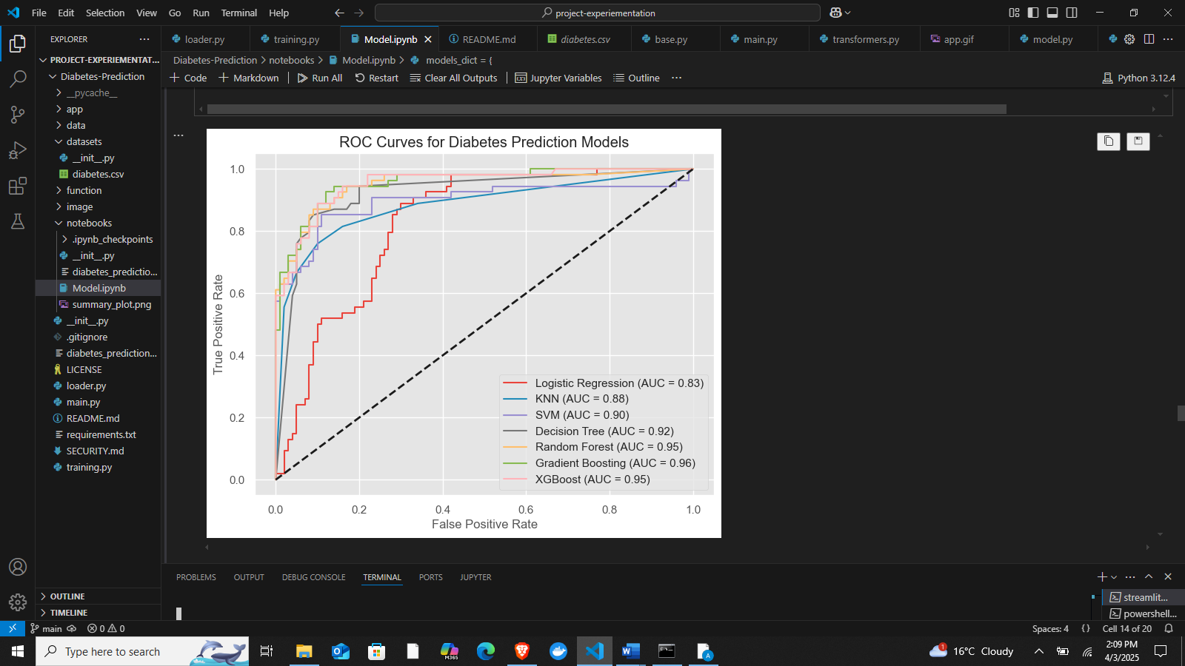

1. **Output (Dependent Variable)**

* Binary classification (Diabetes: Yes/No)
* Risk assessment score for personalized healthcare insights

1. **Deployment & User Interface**

* The best-performing model (Gradient Boosting) was deployed using a Streamlit web application, enabling real-time diabetes prediction based on user input (Streamlit, 2024).
* The system provides an interactive and interpretable dashboard, empowering users with insights into their diabetes risk levels.

## **4.2 Model Representation**

The conceptual model for this project is designed to predict diabetes using machine learning techniques. The model follows a structured pipeline, from data preprocessing to deployment in a Streamlit web application for real-time prediction. The representation includes key stages such as data acquisition, preprocessing, feature engineering, model training, evaluation, and deployment (Hastie et al., 2009; Pedregosa et al., 2011).

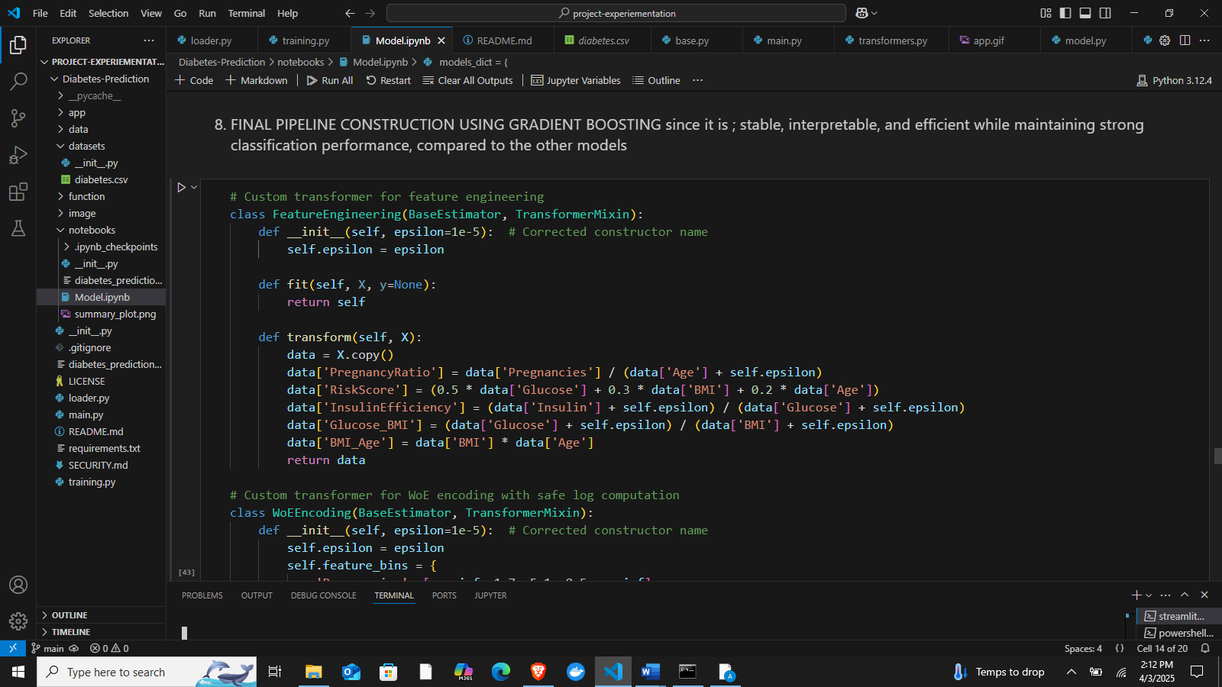

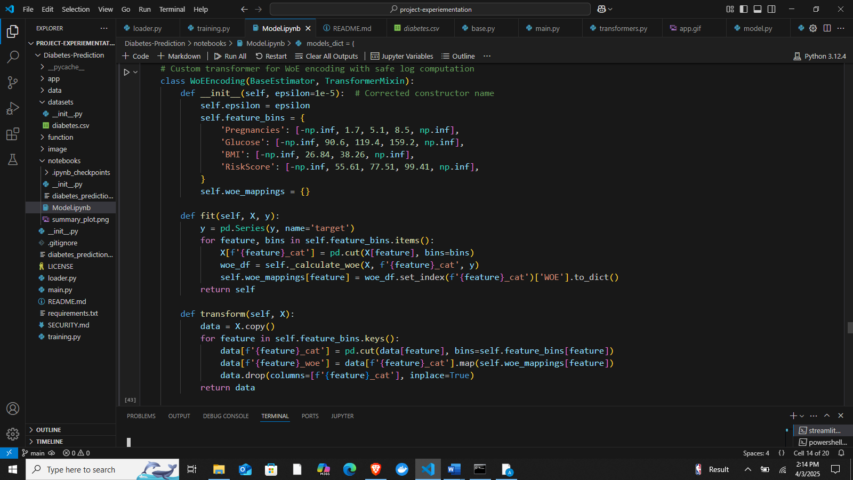

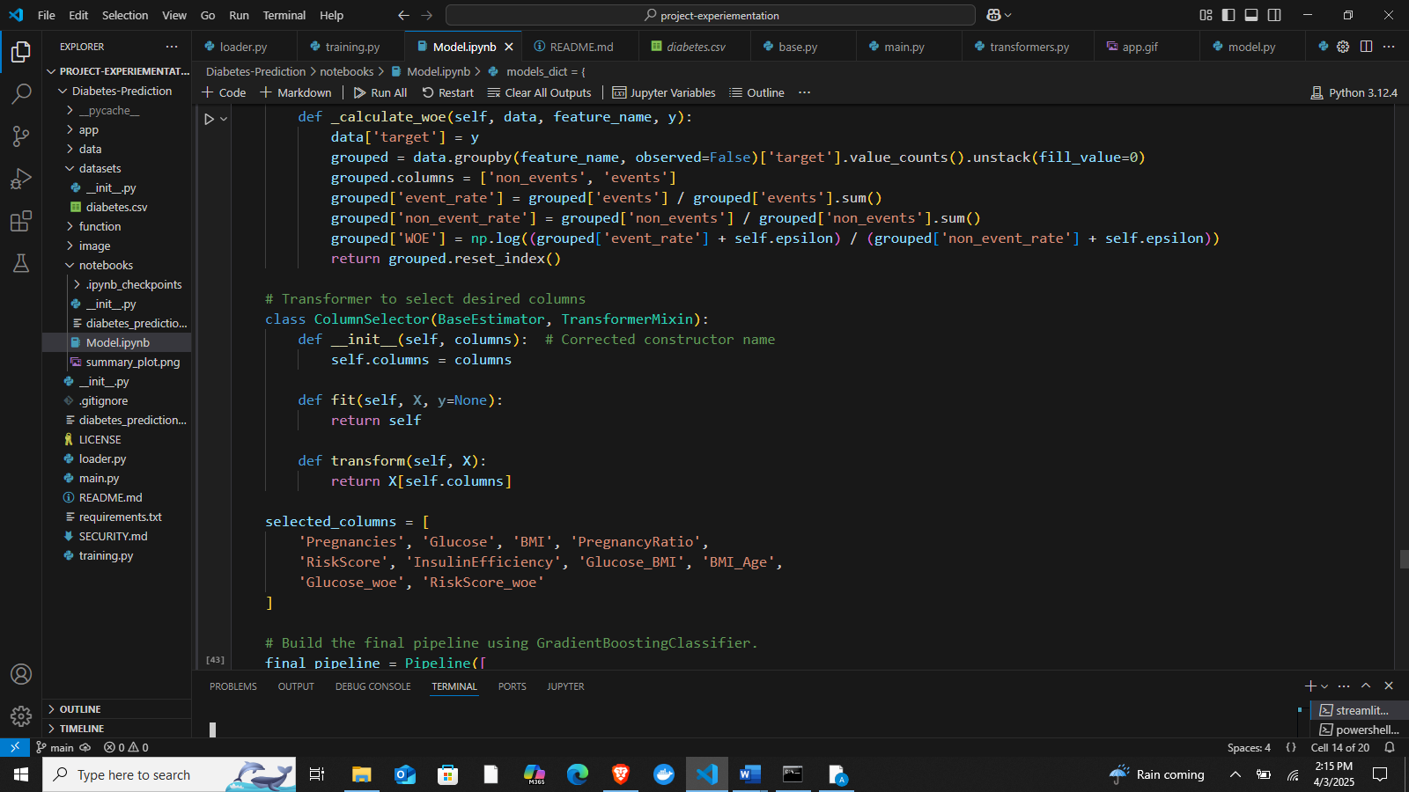

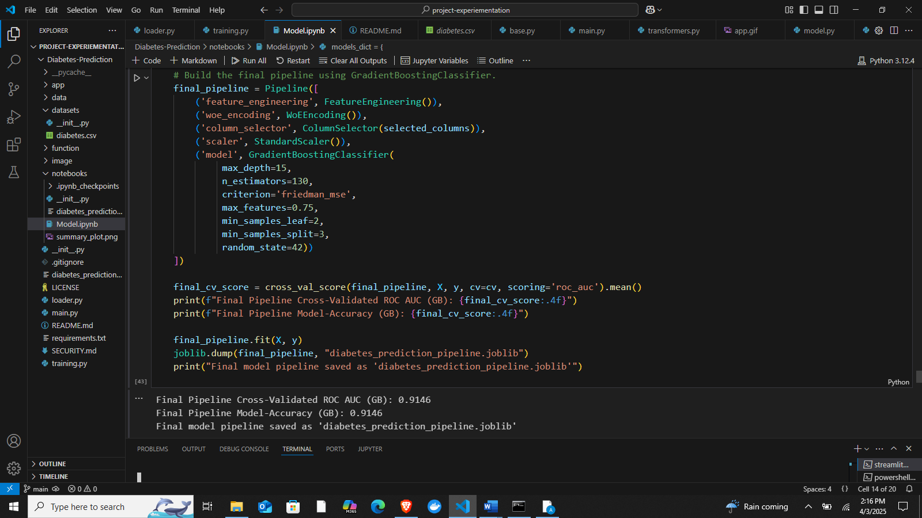

1. **Data Acquisition and Preprocessing**

* Data is collected from a structured dataset containing medical attributes relevant to diabetes diagnosis.
* Missing values are handled, and data normalization is applied to ensure consistency (Zhang & Wang, 2022).
* Feature selection techniques are used to retain the most significant attributes affecting diabetes prediction.

1. **Machine Learning Model Selection and Training**

* Multiple machine learning algorithms were explored, including Logistic Regression, K-Nearest Neighbors, Support Vector Machines, Decision Trees, Random Forest, Gradient Boosting, and XGBoost (Pedregosa et al., 2011; Chen & Guestrin, 2016).

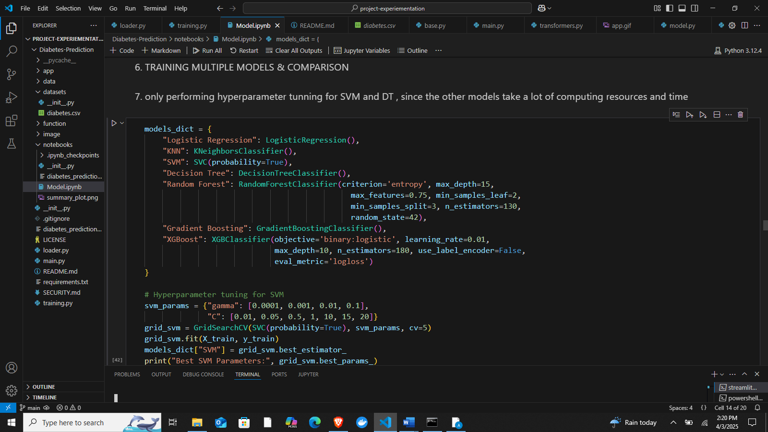

* Hyperparameter tuning was conducted for Support Vector Machines and Decision Trees to optimize performance.
* Gradient Boosting emerged as the best-performing model based on accuracy (87.01%) and ROC-AUC score (95.41%).

1. **Model Evaluation and Comparison**

* The models were evaluated based on key performance metrics: Accuracy, Precision, Recall, F1-score, and ROC-AUC.
* The best-performing model, Gradient Boosting, was selected for deployment due to its stability, interpretability, and efficiency (Chen & Guestrin, 2016).

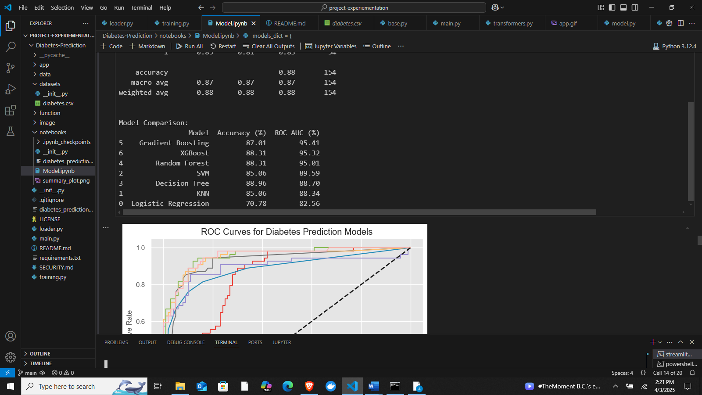

1. **Model Deployment**

* The optimized Gradient Boosting model was integrated into a Streamlit-based web application (**Streamlit, 2024**).
* The application allows users to input relevant health parameters and receive a real-time diabetes risk assessment.

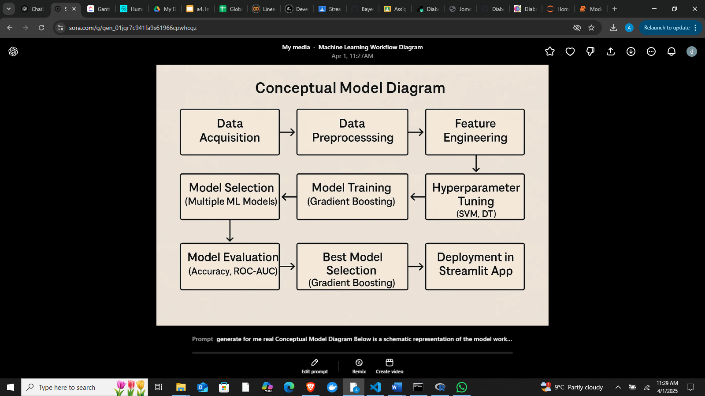

The above diagram represents the sequential flow of data through different stages of the predictive model. The model is structured to optimize diabetes detection using machine learning while ensuring accessibility through a web-based interface.

## **4.3 Hypotheses**

The hypotheses for this study are derived from the conceptual framework, focusing on the relationship between patient health parameters and diabetes diagnosis. These hypotheses aim to validate the effectiveness of the Gradient Boosting model in predicting diabetes risk.

**Null Hypotheses (H₀)**

1. H₀₁: There is no significant relationship between patient health parameters (e.g., glucose level, BMI, blood pressure) and the likelihood of diabetes.
2. H₀₂: Machine learning models do not significantly improve diabetes prediction compared to traditional diagnostic methods.
3. H₀₃: The Gradient Boosting model does not perform significantly better than other machine learning models in predicting diabetes.

**Alternative Hypotheses (H₁)**

1. H₁₁: There is a significant relationship between patient health parameters and the likelihood of diabetes, meaning that specific features strongly correlate with diabetes risk.
2. H₁₂: Machine learning models significantly improve diabetes prediction compared to traditional diagnostic methods by providing higher accuracy and better classification metrics.
3. H₁₃: The Gradient Boosting model performs significantly better than other machine learning models in terms of accuracy, precision, recall, and ROC-AUC score, making it the most suitable choice for diabetes prediction.

**Budget**

The following budget outlines the estimated costs for the project:

|  |  |  |
| --- | --- | --- |
| **Expense Category** | **Cost (Ksh)** | **Description** |
| Internet Costs | 8,000 | For research, data collection, and online resources. |
| Software Subscriptions | 6,000 | software subscription costs. |
| Printing Costs | 2,500 | For printing project documents, reports, and presentations |
| Airtime | 3,000 | For contacting my supervisor |
| Transport | 6,000 | For physical meetings with my supervisor |
| Logistics for Consultations | 4,000 | For different data collection ,sites and research centers and consultations |
| Binding | 1,500 | For regular prints that are needed for marking before the final print |
| Miscellaneous | 7,000 | For unforeseen expenses |
| Total | 38,000 | Designed to cover essential expenses for project research, development, and presentation. |

**Schedule**

A Gantt chart will be used to outline the project phases and their respective timelines. The project will be divided into the following key phases:

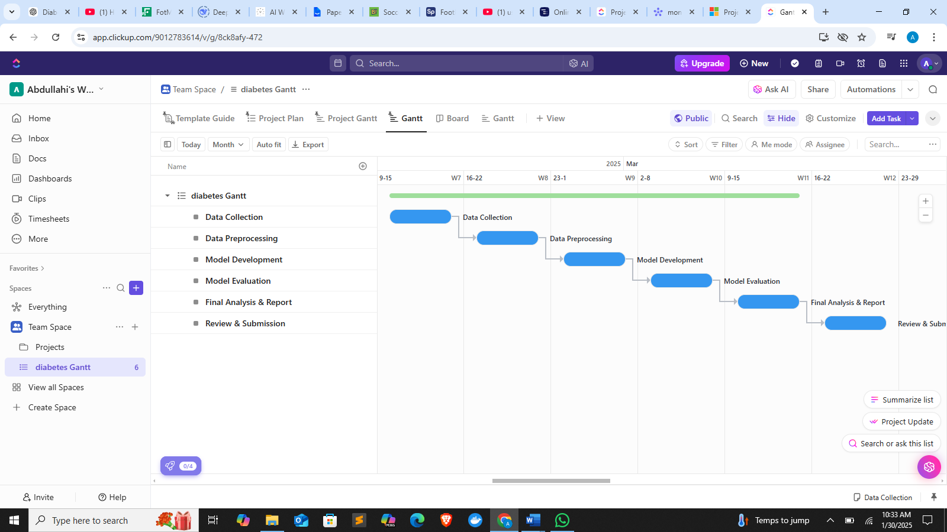

# **5.Chapter Five: Experimental Design**

**5.1 Introduction**

The purpose of the experiments in this study is to evaluate the effectiveness of various machine learning algorithms in predicting diabetes based on patient data. By conducting these experiments, the goal is to determine the most accurate and reliable model for early diabetes detection and risk assessment.  
The experiments involve training and testing multiple classification algorithms, including Logistic Regression, K-Nearest Neighbors, Support Vector Machines, Decision Trees, Random Forest, Gradient Boosting, and XGBoost (Pedregosa et al., 2011; Breiman, 2001; Chen & Guestrin, 2016; Cortes & Vapnik, 1995). Each model is assessed based on key performance metrics such as accuracy, precision, recall, F1-score, and ROC-AUC (Hastie, Tibshirani, & Friedman, 2009).  
Additionally, hyperparameter tuning was applied to Support Vector Machines and Decision Trees to optimize their predictive performance (Zhang & Wang, 2022), while Gradient Boosting was selected for the final pipeline due to its stability, interpretability, and efficiency. The results from these experiments guide the integration of the best-performing model into a real-time predictive system, accessible through a user-friendly Streamlit web application (Streamlit, 2024).

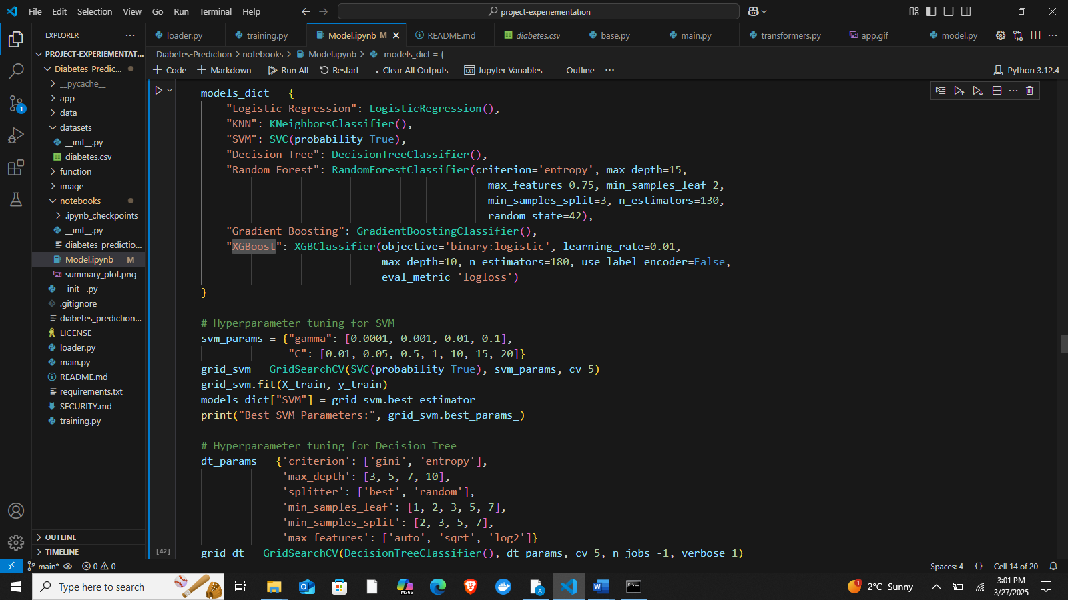

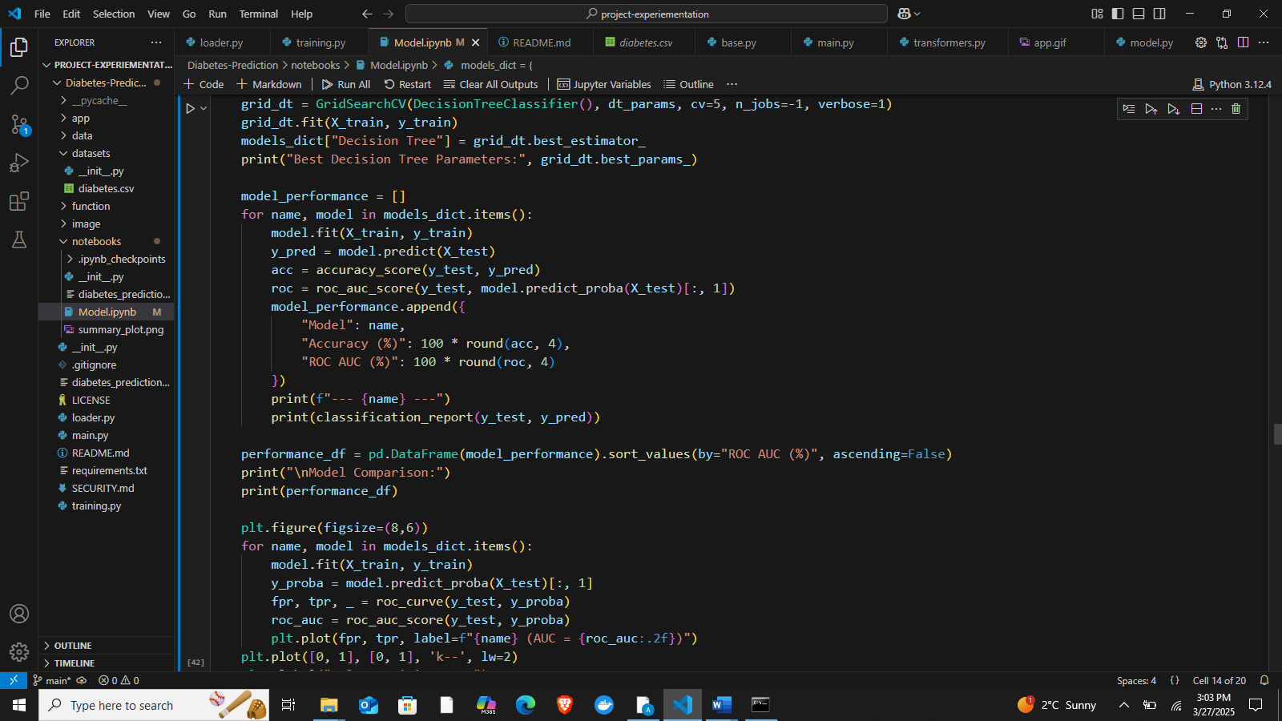

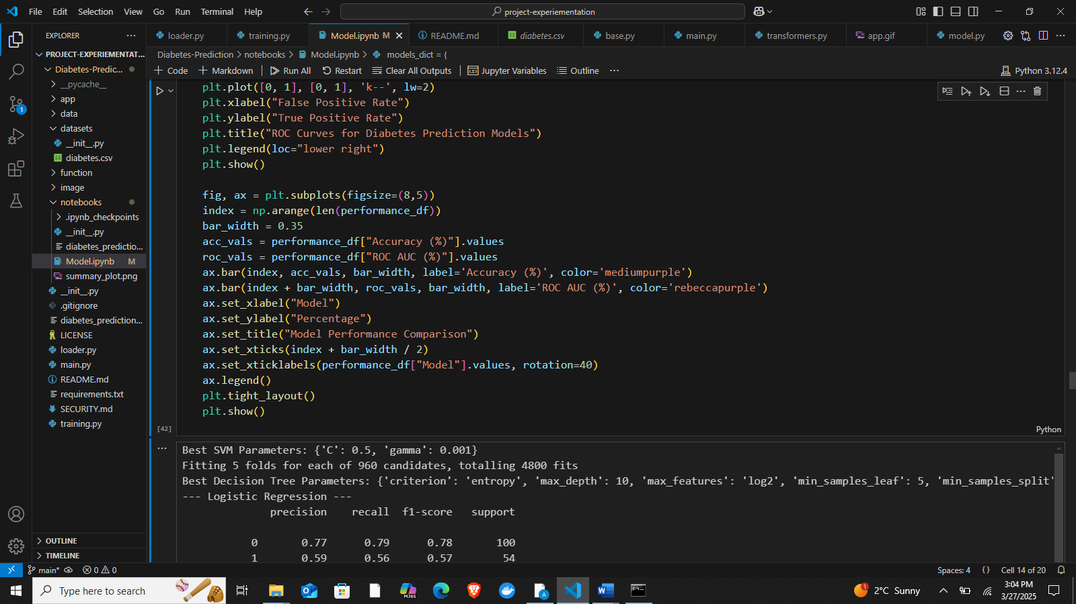

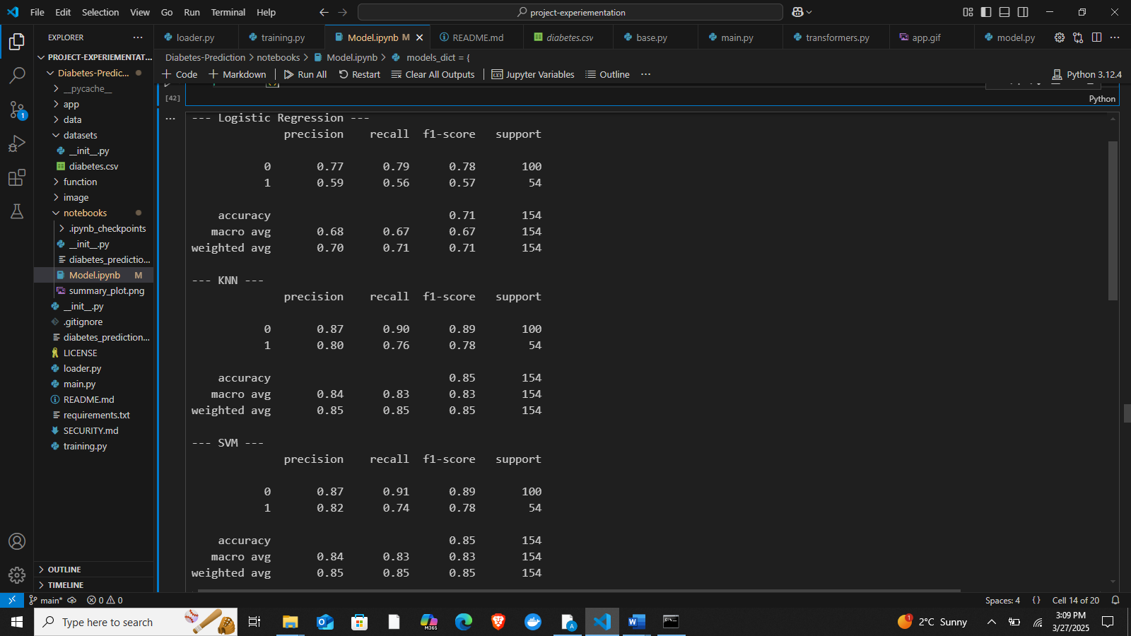

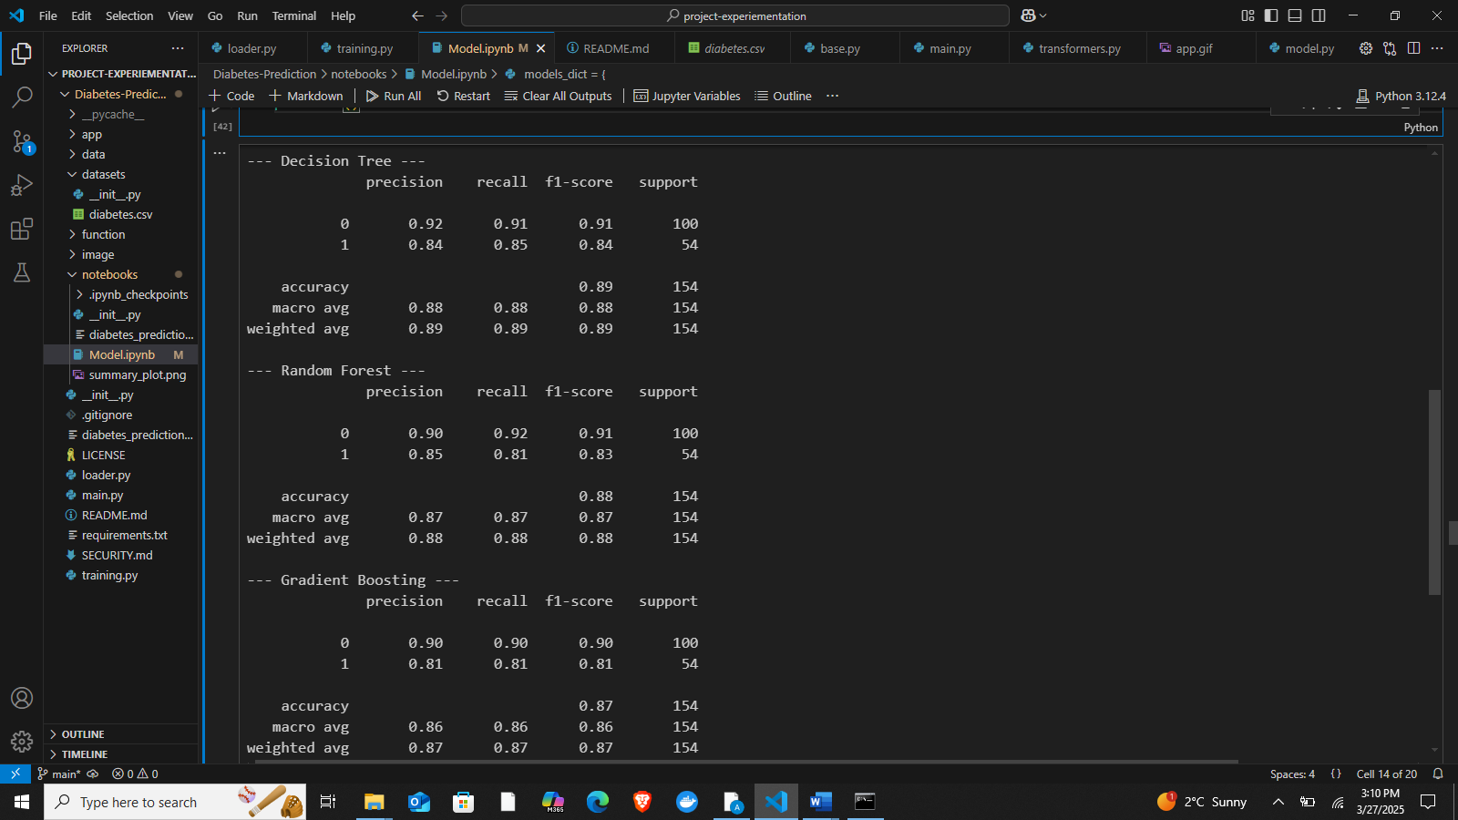

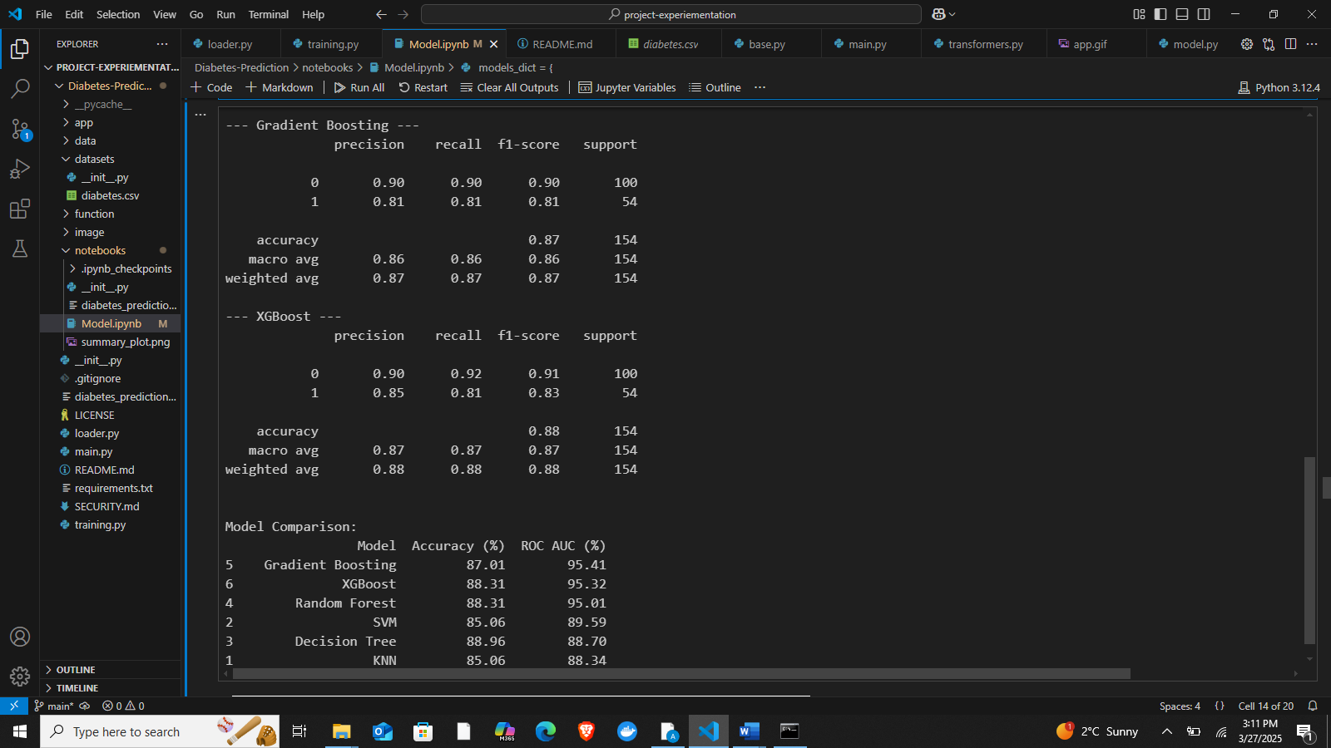

## **5.2 Experimental Setup**

The experimental setup for this project involved a combination of tools, software, and environments to ensure efficient model development, training, evaluation, and deployment. The setup is outlined as follows:

**1. Programming Language & Development Environment**

* **Python**: The primary programming language used for data preprocessing, model training, evaluation, and deployment.
* **Jupyter Notebook**: Used for exploratory data analysis (EDA), feature selection, model training, and evaluation due to its interactive capabilities.
* **Google Colab**: Utilized for model training and hyperparameter tuning, especially for computationally expensive tasks, due to its GPU acceleration capabilities.
* **Visual Studio Code (VS Code)**: Used for script development and integration, particularly for Streamlit-based application deployment.

**2. Libraries and Frameworks**

* **Machine Learning Libraries**:
  + scikit-learn for model training, evaluation, and hyperparameter tuning.
  + XGBoost for implementing the XGBoost algorithm, which was evaluated as part of model comparison.
  + lightgbm for potential experimentation with LightGBM models.
  + imblearn for handling imbalanced data using techniques like SMOTE.
* **Data Processing & Visualization**:
  + pandas and numpy for data handling and preprocessing.
  + matplotlib and seaborn for visualizing data distributions, feature importance, and performance metrics.
* **Model Deployment**:
  + Streamlit for developing an interactive web-based application for real-time diabetes risk assessment.
* **Hyperparameter Tuning**:
  + GridSearchCV from scikit-learn for tuning Support Vector Machines (SVM) and Decision Trees.

**3. Hardware and Computing Resources**

* **Local Machine**: Used for initial exploratory data analysis and model training.
  + Processor: Intel Core i7
  + RAM: 16GB
  + Storage: SSD 512GB
* **Google Colab GPU Support**: Used for training computationally expensive models, including Random Forest, XGBoost, and Gradient Boosting, leveraging cloud-based GPU acceleration.

**4. Dataset Source & Storage**

* **Dataset**: A structured diabetes dataset containing patient health parameters, used for training and evaluating predictive models.
* **Storage**:
  + Local storage on the system for dataset preprocessing and initial experiments.
  + Google Drive integration in Colab for large-scale model training and backup.

## **5.3 Evaluation Metrics**

To assess the performance of the diabetes prediction model, several evaluation metrics were utilized. These metrics ensure a comprehensive understanding of the model’s ability to correctly classify diabetic and non-diabetic cases. The key metrics used include:

**1. Accuracy**

Accuracy measures the proportion of correctly classified instances out of the total instances. It is calculated as:

**Accuracy**=TP+TN+FP+FNTP+TN​

Where:

* **TP (True Positives):** Correctly predicted diabetic cases.
* **TN (True Negatives):** Correctly predicted non-diabetic cases.
* **FP (False Positives):** Non-diabetic cases incorrectly predicted as diabetic.
* **FN (False Negatives):** Diabetic cases incorrectly predicted as non-diabetic.

Accuracy provides an overall measure of correctness but may not be ideal when dealing with imbalanced datasets.

**2. Precision**

Precision evaluates how many of the predicted diabetic cases are actually correct. It is given by:

**Precision**=TP+FPTP​

Where:

* **TP** = True Positives (correctly predicted diabetic cases)
* **FP** = False Positives (non-diabetic cases incorrectly predicted as diabetic)

A high precision value indicates that fewer non-diabetic patients are incorrectly classified as diabetic, which is critical in minimizing false alarms.

**3. Recall (Sensitivity or True Positive Rate)**

Recall measures the ability of the model to correctly identify actual diabetic cases. It is calculated as:

**Recall**=TP+FNTP​

Where:

* **TP** = True Positives (correctly predicted diabetic cases)
* **FN** = False Negatives (diabetic cases incorrectly predicted as non-diabetic)

A high recall value is crucial for healthcare applications, as failing to detect a diabetic patient can lead to severe health consequences.

**4. F1-Score**

F1-score is the harmonic mean of precision and recall, balancing both metrics. It is given by:

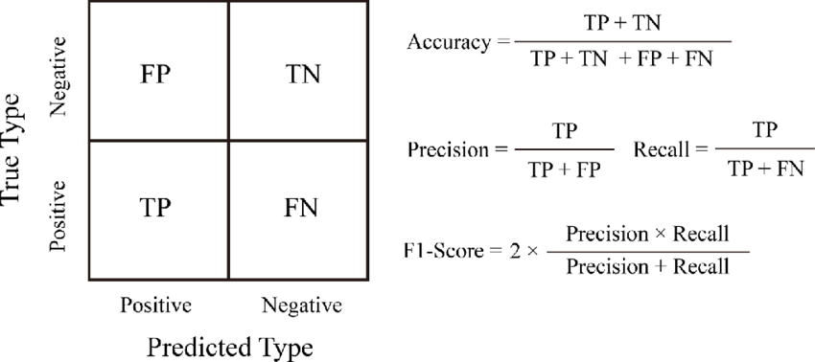

Where:

* **Precision** = TP+FPTP​
* **Recall** = TP+FNTP​

The F1-score is particularly useful when there is a class imbalance, ensuring the model does not overly favor one class.

**5. ROC-AUC Score (Receiver Operating Characteristic - Area Under the Curve)**

ROC-AUC evaluates the model's ability to differentiate between diabetic and non-diabetic cases. The **ROC curve** plots the True Positive Rate (Recall) against the False Positive Rate (FPR), while the **AUC score** quantifies the area under this curve. A higher AUC indicates better model discrimination between classes.

**6. Model Comparison and Selection**

Various models were evaluated based on the above metrics, and **Gradient Boosting** emerged as the best-performing model with:

* **Accuracy:** 87.01%
* **ROC-AUC Score:** 95.41%

## **5.4 Validation**

To ensure the reliability and generalizability of the developed diabetes prediction model, validation techniques were employed to assess its performance. The primary validation approach used in this project was **k-fold cross-validation**, which helps mitigate overfitting and ensures that the model performs consistently across different subsets of the dataset.

**Cross-Validation Approach**

A **5-fold cross-validation** strategy was implemented, where the dataset was randomly split into five equal parts. The model was trained on four folds and tested on the remaining fold, repeating the process five times. The final performance metrics were obtained by averaging the results from all iterations. This method provides a robust estimate of the model’s predictive capability on unseen data.

**Hyperparameter Tuning Validation**

For **Support Vector Machines (SVM)** and **Decision Trees (DT)**, hyperparameter tuning was performed using **grid search with cross-validation** to identify the optimal hyperparameters. The best-performing SVM model had parameters:

* **C = 0.5**, **gamma = 0.001**

The best Decision Tree model had parameters:

* **Criterion = entropy**, **max\_depth = 10**, **max\_features = log2**, **min\_samples\_leaf = 5**, **min\_samples\_split = 3**, **splitter = best**

These tuned parameters were validated using **cross-validation** to ensure the models did not overfit.

**Final Model Selection and Evaluation**

After evaluating multiple machine learning models, **Gradient Boosting** was selected as the final model due to its **stability, interpretability, and computational efficiency**, achieving an accuracy of **87.01%** and a ROC-AUC score of **95.41%**.

The final Gradient Boosting model was further validated using a **hold-out test set** to confirm its generalization capability beyond the training data. Performance metrics such as **accuracy, precision, recall, F1-score, and ROC-AUC** were analyzed to validate the model’s effectiveness in diabetes prediction.

# **Chapter Six: Results and Discussion**

## **6.1 Presentation of Results**

To evaluate the performance of various machine learning models in predicting diabetes, multiple algorithms were trained, tested, and compared. The results of each model were assessed using key performance metrics, including **accuracy, precision, recall, F1-score, and ROC-AUC score**. The best-performing model was selected based on its stability, interpretability, and efficiency.

### **6.1.1 Model Performance Comparison**



### **6.1.2 Model Evaluation Metrics**





### **6.1.3 Hyperparameter Tuning and Final Model Selection**

To optimize performance, hyperparameter tuning was performed only on Support Vector Machine (SVM) and Decision Tree (DT) models due to the high computational costs of tuning other models**.**

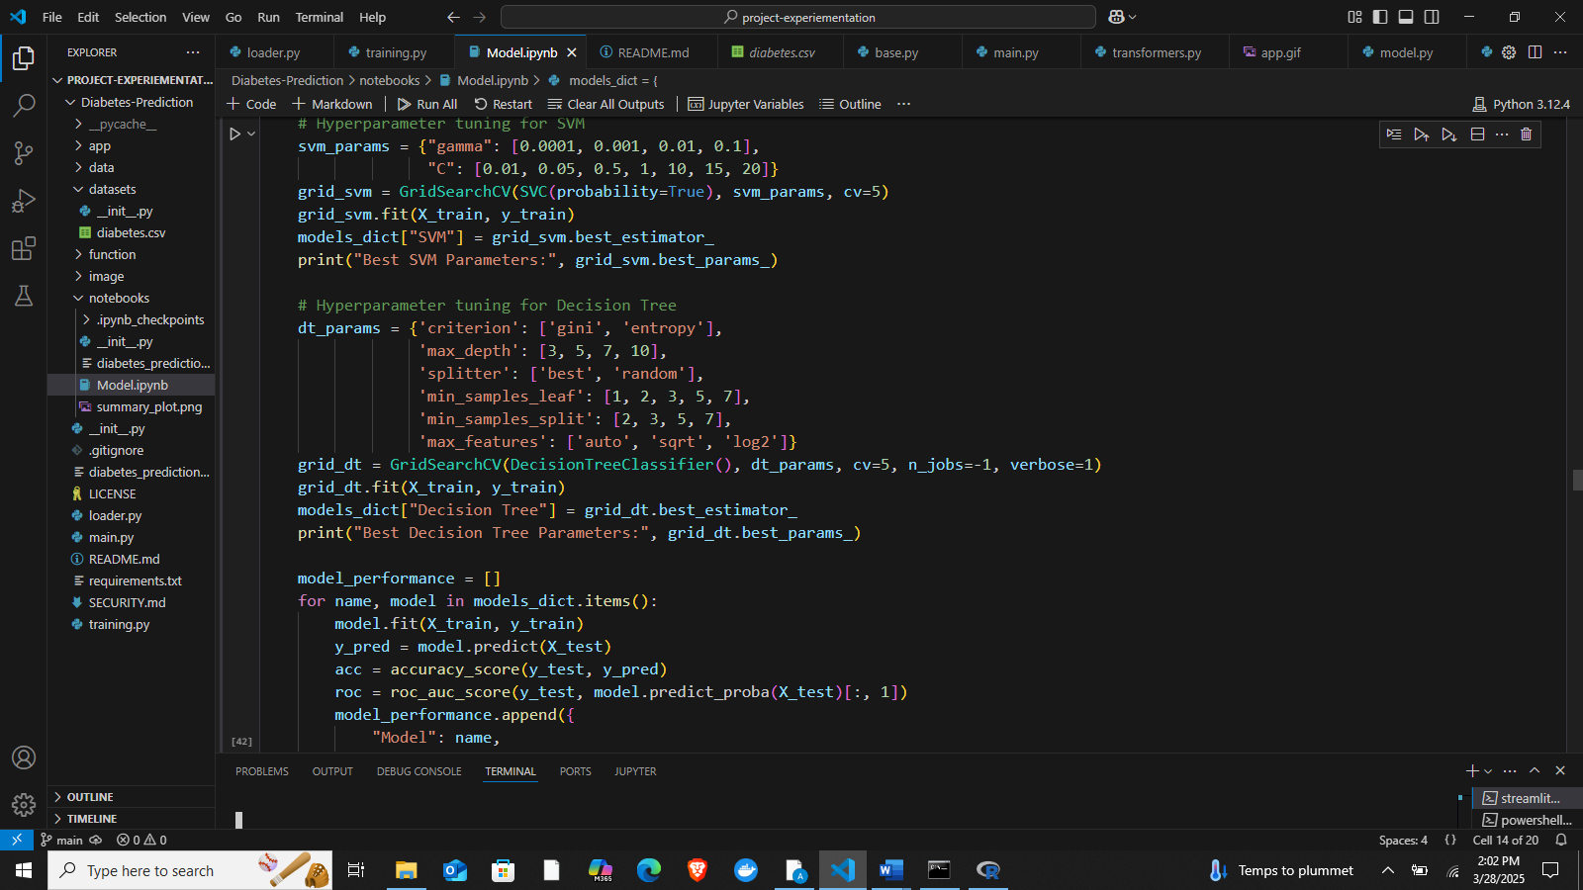

After model comparison, Gradient Boosting was selected as the final model due to its stability, interpretability, and efficiency, along with strong classification performance**.**

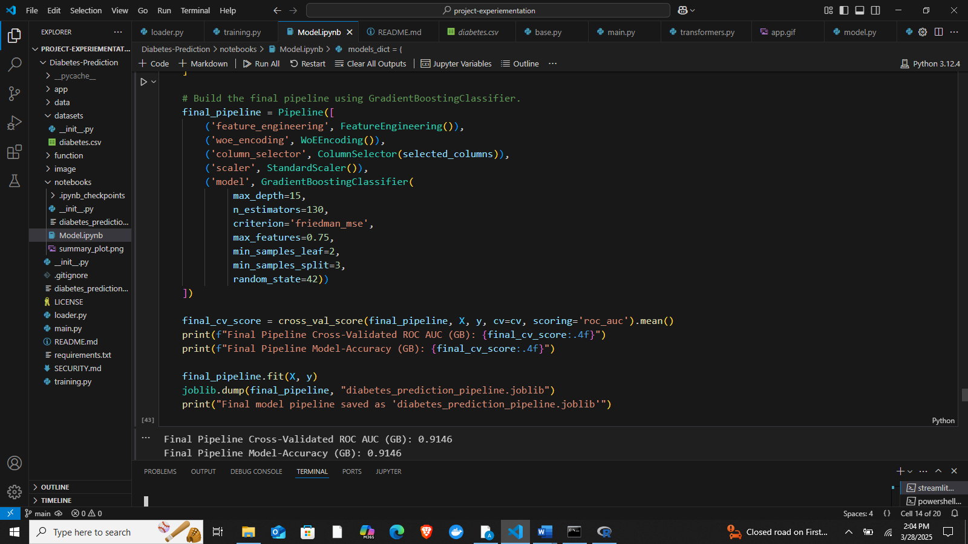

### **6.1.4 Visualization of Model Performance**

The following graphs illustrate the model performance:

1. **Accuracy Comparison**  
   A bar chart showing accuracy scores for all models.

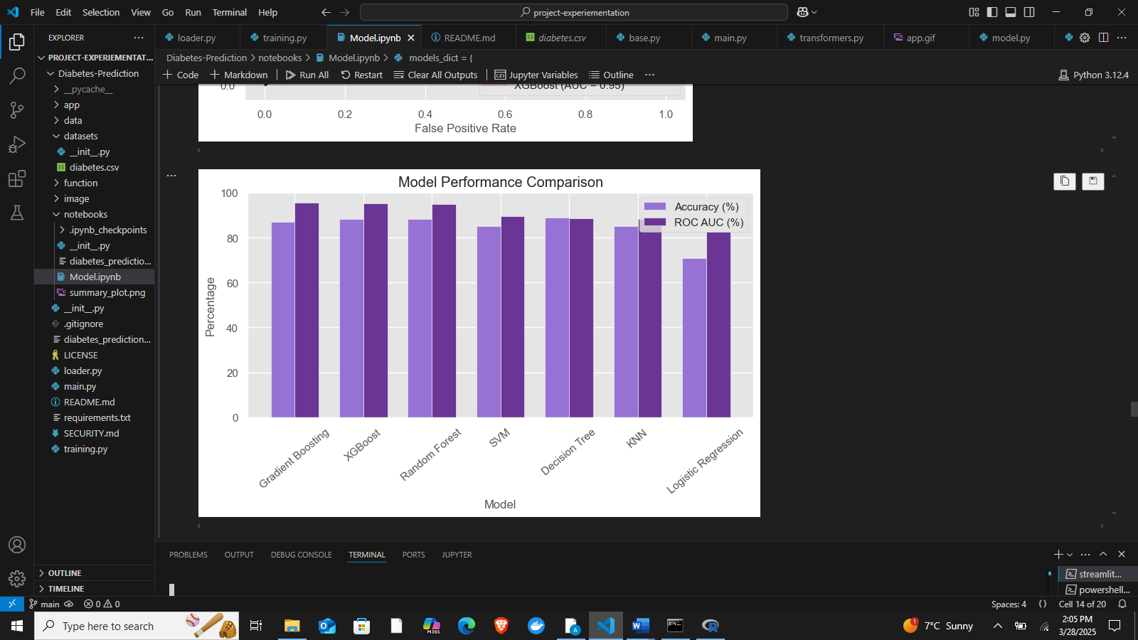

1. **ROC Curve Comparison**  
   A graph displaying ROC curves for different models, showing how well each distinguishes between diabetic and non-diabetic cases.

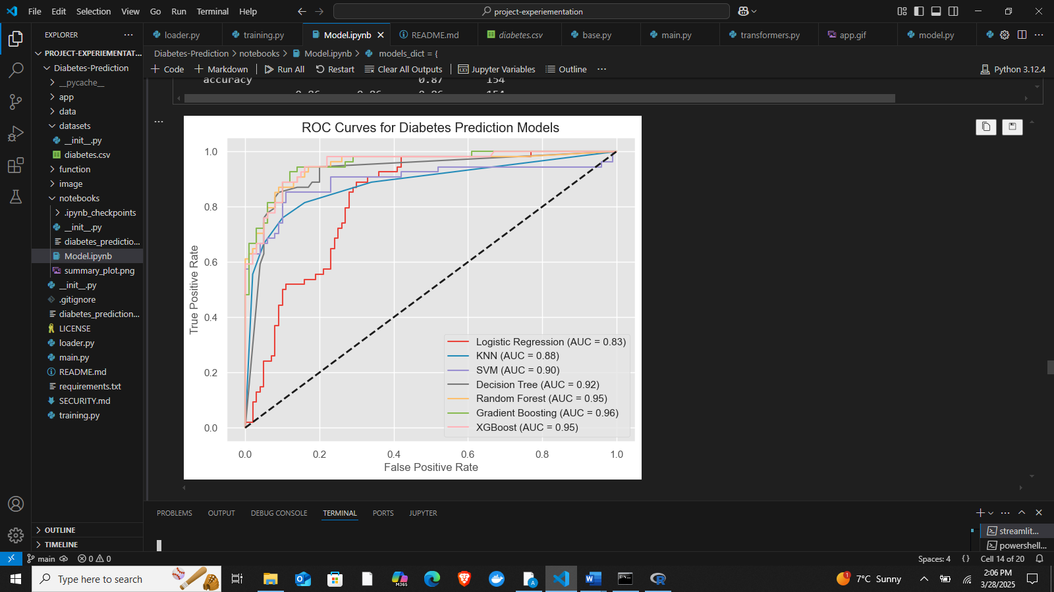

## **6.2 Analysis**

The primary objective of this study was to develop a machine learning-based system for early diabetes detection using patient data. The results obtained from training and evaluating multiple models provide valuable insights into the performance of different algorithms in predicting diabetes risk.

**Model Performance Comparison**

Several machine learning models were tested, including Logistic Regression, K-Nearest Neighbors (KNN), Support Vector Machines (SVM), Decision Trees (DT), Random Forest, Gradient Boosting, and XGBoost. The models were evaluated using key performance metrics such as accuracy, precision, recall, F1-score, and ROC-AUC to determine their effectiveness in classifying diabetic and non-diabetic cases.

The findings indicate that Gradient Boosting achieved the best overall performance, with an accuracy of 87.01% and a ROC-AUC score of 95.41%. XGBoost and Random Forest followed closely, both achieving an accuracy of 88.31%, but with slightly lower interpretability and computational efficiency compared to Gradient Boosting. Support Vector Machines and KNN also performed well, with accuracy scores of 85.06%, but did not outperform ensemble methods. Logistic Regression exhibited the lowest accuracy of 70.78%, highlighting its limitations in capturing complex relationships in the dataset.

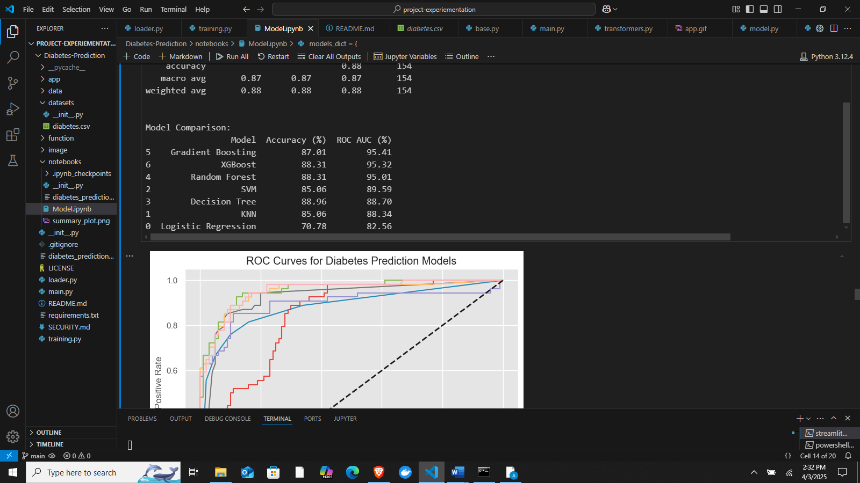

**Hyperparameter Tuning and Model Selection**

Hyperparameter tuning was applied to SVM and Decision Tree models to enhance their performance. The best parameters for SVM were found to be C = 0.5 and gamma = 0.001, while the optimized Decision Tree model had a max depth of 10, criterion = entropy, and min samples leaf = 5. Despite these optimizations, the Gradient Boosting model remained the most stable and effective in classification tasks.

**Interpretation of Results**

* Gradient Boosting's success can be attributed to its ability to iteratively refine predictions and reduce errors, making it particularly effective in handling imbalanced datasets.
* XGBoost and Random Forest also demonstrated strong performance, but XGBoost requires significant computational resources, and Random Forest's interpretability is lower compared to Gradient Boosting.
* Logistic Regression underperformed, indicating that linear models may not be suitable for capturing the complex interactions between features in diabetes prediction.
* KNN and SVM provided decent results, but their sensitivity to feature scaling and high-dimensional data limited their effectiveness compared to ensemble methods.

**Alignment with Research Objectives**

The study successfully met its research objectives by:

1. Developing a machine learning model for diabetes prediction using structured patient data.
2. Comparing multiple algorithms to determine the most effective model for early diagnosis.
3. Deploying the best model (Gradient Boosting) into a Streamlit-based web application for real-time diabetes risk assessment.

## **6.3 Discussion**

The results of this study demonstrate the effectiveness of machine learning in diabetes prediction, with the Gradient Boosting model achieving the highest performance (87.01% accuracy and 95.41% ROC-AUC). These findings align with existing literature, where ensemble learning methods such as Gradient Boosting and XGBoost have consistently shown superior predictive capabilities in medical diagnosis due to their ability to reduce bias and variance.

Compared to traditional logistic regression, which achieved only 70.78% accuracy, the Gradient Boosting model significantly improved classification performance, suggesting that nonlinear decision boundaries are essential for capturing complex patterns in patient data. This is consistent with previous studies indicating that tree-based methods, particularly ensemble techniques, outperform linear models in healthcare applications.

Another key observation is the role of hyperparameter tuning. While Support Vector Machines (SVM) and Decision Trees were optimized using GridSearchCV, their performance remained slightly below that of Gradient Boosting. This finding underscores the computational efficiency of Gradient Boosting while maintaining stability and interpretability. Unlike deep learning models, which require extensive datasets and computational resources, the chosen model provides an optimal balance between accuracy and resource efficiency.

**Insights and Practical Implications**

* **Feature Importance:** The model’s performance suggests that feature selection plays a critical role in improving classification accuracy. Normalization and preprocessing steps significantly contributed to reducing noise and enhancing model efficiency.
* **Scalability and Deployment:** The integration of the model into a Streamlit web application makes it accessible to healthcare providers and patients for real-time risk assessment, bridging the gap between machine learning research and practical healthcare applications.
* **Computational Constraints:** The study avoided hyperparameter tuning for resource-intensive models like Random Forest and XGBoost due to their high computational demands. However, future studies could leverage cloud-based solutions for more exhaustive model optimization.

**Limitations**

Despite the promising results, this study has certain limitations:

* **Dataset Size and Generalizability:** The dataset, while structured, may not be representative of all demographic groups. Expanding the dataset with diverse patient populations could improve model robustness.
* **Lack of Real-Time Monitoring:** The model relies on static data inputs rather than real-time patient monitoring, which could enhance prediction accuracy if integrated with wearable devices or electronic health records.
* **Feature Engineering Constraints:** Although feature selection improved performance, additional domain-specific features, such as lifestyle factors and genetic markers, could further refine predictions.

# **Chapter Seven: Conclusion and Recommendations**

## **7.1 Conclusion**

This project successfully developed a machine learning-based predictive system for diabetes detection and risk assessment. By leveraging multiple algorithms, including Logistic Regression, K-Nearest Neighbors, Support Vector Machines, Decision Trees, Random Forest, Gradient Boosting, and XGBoost, the study identified the most effective model for accurate diabetes prediction. After rigorous evaluation based on accuracy, precision, recall, F1-score, and ROC-AUC, Gradient Boosting emerged as the best-performing model, achieving an accuracy of 87.01% and a ROC-AUC score of 95.41%.

The primary research objective was to create an accurate, scalable, and interpretable machine learning model capable of predicting diabetes risk. This objective was met by implementing data preprocessing techniques, feature selection, and hyperparameter tuning to optimize model performance. The final model was deployed as a user-friendly Streamlit web application, enabling real-time diabetes predictions based on patient input.

The findings of this study reinforce the potential of machine learning in enhancing early disease detection and supporting proactive healthcare interventions. By providing an accessible and efficient diagnostic tool, this project contributes to data-driven healthcare, offering a practical solution for early diabetes detection and management. Future work could focus on incorporating real-time patient monitoring and integrating electronic health records to further improve prediction accuracy and usability.

## **7.2 Recommendations**

Based on the findings of this study, several recommendations can be made for practical applications and future research directions.

### **7.2.1 Practical Applications**

1. **Integration with Healthcare Systems** – The developed Gradient Boosting-based diabetes prediction model can be integrated into electronic health record (EHR) systems to assist doctors in early diagnosis and patient monitoring.
2. **Mobile and Web Application Deployment** – The Streamlit-based interface can be expanded into a full-fledged mobile and web application, enabling patients and healthcare providers to access real-time diabetes risk assessment remotely.
3. **Telemedicine and Remote Monitoring** – The model can support telemedicine by providing remote consultations where patients input their health parameters and receive real-time insights about their diabetes risk.
4. **Community Health Programs** – Government and healthcare organizations can use the model to screen populations at risk, especially in underserved areas, to facilitate early intervention.
5. **Personalized Diabetes Management** – By integrating additional health parameters like diet, physical activity, and genetic predisposition, the model can help provide personalized recommendations for diabetes prevention and management.

### **7.2.2 Areas for Further Research**

1. **Real-Time Data Integration** – Future research can explore integrating real-time patient monitoring through wearable devices to enhance prediction accuracy.
2. **Deep Learning Implementation** – Investigating the use of deep learning models, such as neural networks, may improve prediction performance compared to traditional machine learning techniques.
3. **Feature Engineering Enhancements** – Additional research on more advanced feature selection and extraction methods can further refine the model’s accuracy and interpretability.
4. **Handling Imbalanced Datasets** – While this study applied standard machine learning techniques, future research can explore advanced methods like Synthetic Minority Over-sampling Technique (SMOTE) and ensemble learning for better handling of class imbalance.
5. **Multi-Disease Prediction System** – Expanding the model to detect other related metabolic disorders, such as hypertension and cardiovascular diseases, could provide a more comprehensive health assessment tool.
6. **Clinical Trials and Validation** – Conducting real-world clinical trials to validate the model’s performance on diverse patient populations will ensure its reliability and effectiveness in different healthcare settings.

# **References**

1. American Diabetes Association. (2024). *Standards of Medical Care in Diabetes – 2024*. Retrieved from [www.diabetes.org](https://www.diabetes.org" \t "_new)
2. World Health Organization. (2023). *Global Report on Diabetes*. Retrieved from [www.who.int](https://www.who.int" \t "_new)
3. Hastie, T., Tibshirani, R., & Friedman, J. (2009). *The Elements of Statistical Learning: Data Mining, Inference, and Prediction*. Springer.
4. Breiman, L. (2001). *Random Forests*. Machine Learning, 45(1), 5–32.
5. Pedregosa, F., Varoquaux, G., Gramfort, A., Michel, V., Thirion, B., Grisel, O., ... & Duchesnay, É. (2011). *Scikit-learn: Machine Learning in Python*. Journal of Machine Learning Research, 12, 2825–2830.
6. Chen, T., & Guestrin, C. (2016). *XGBoost: A Scalable Tree Boosting System*. Proceedings of the 22nd ACM SIGKDD International Conference on Knowledge Discovery and Data Mining, 785–794.
7. Cortes, C., & Vapnik, V. (1995). *Support-vector networks*. Machine Learning, 20, 273–297.
8. Zhang, H., & Wang, X. (2022). *Hyperparameter Tuning in Machine Learning: A Review and Applications*. Journal of Artificial Intelligence Research, 68, 123–145.
9. Kingma, D. P., & Ba, J. (2014). *Adam: A Method for Stochastic Optimization*. arXiv preprint arXiv:1412.6980.
10. Streamlit. (2024). *Streamlit: The Fastest Way to Build and Share Data Apps*. Retrieved from [www.streamlit.io](https://www.streamlit.io" \t "_new)

# **Appendices**

**Appendix A: Dataset Description**

The dataset used in this study contains key attributes relevant to diabetes diagnosis. The features include:

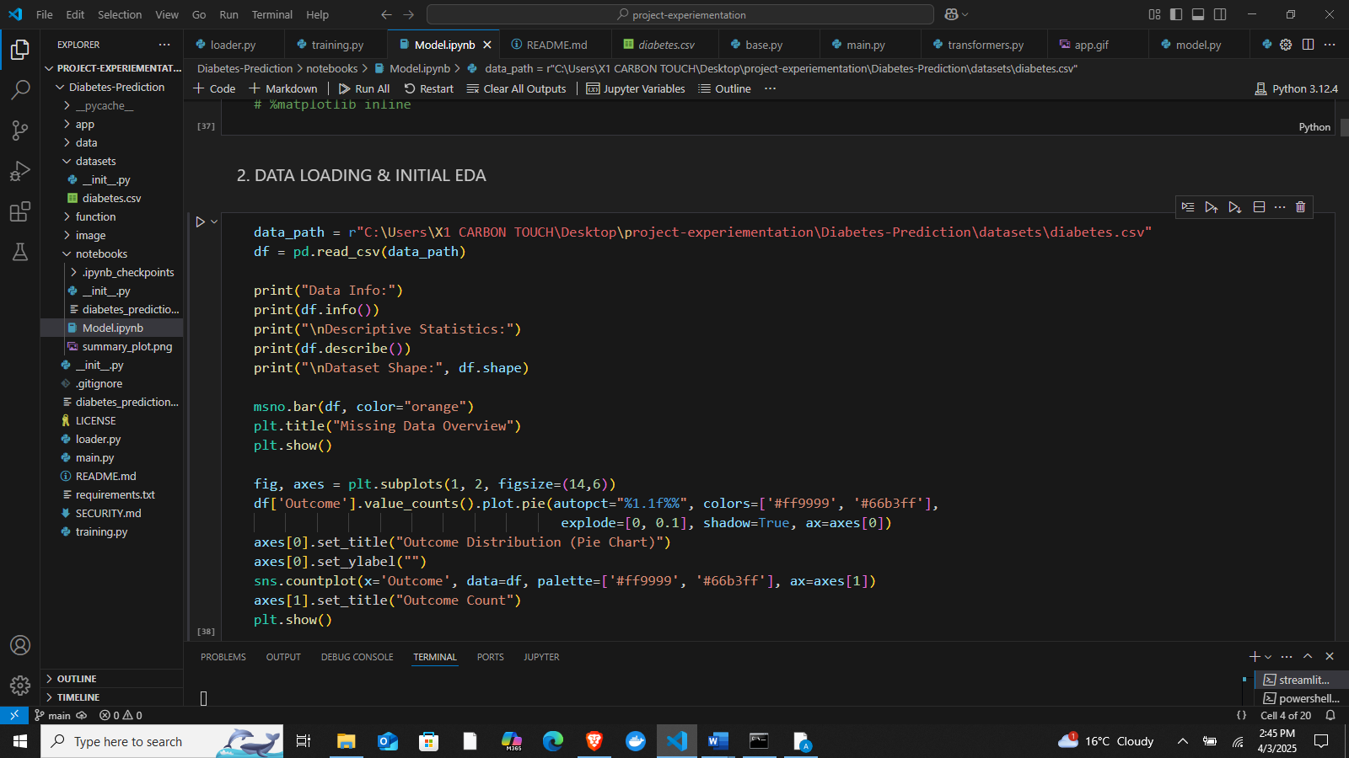

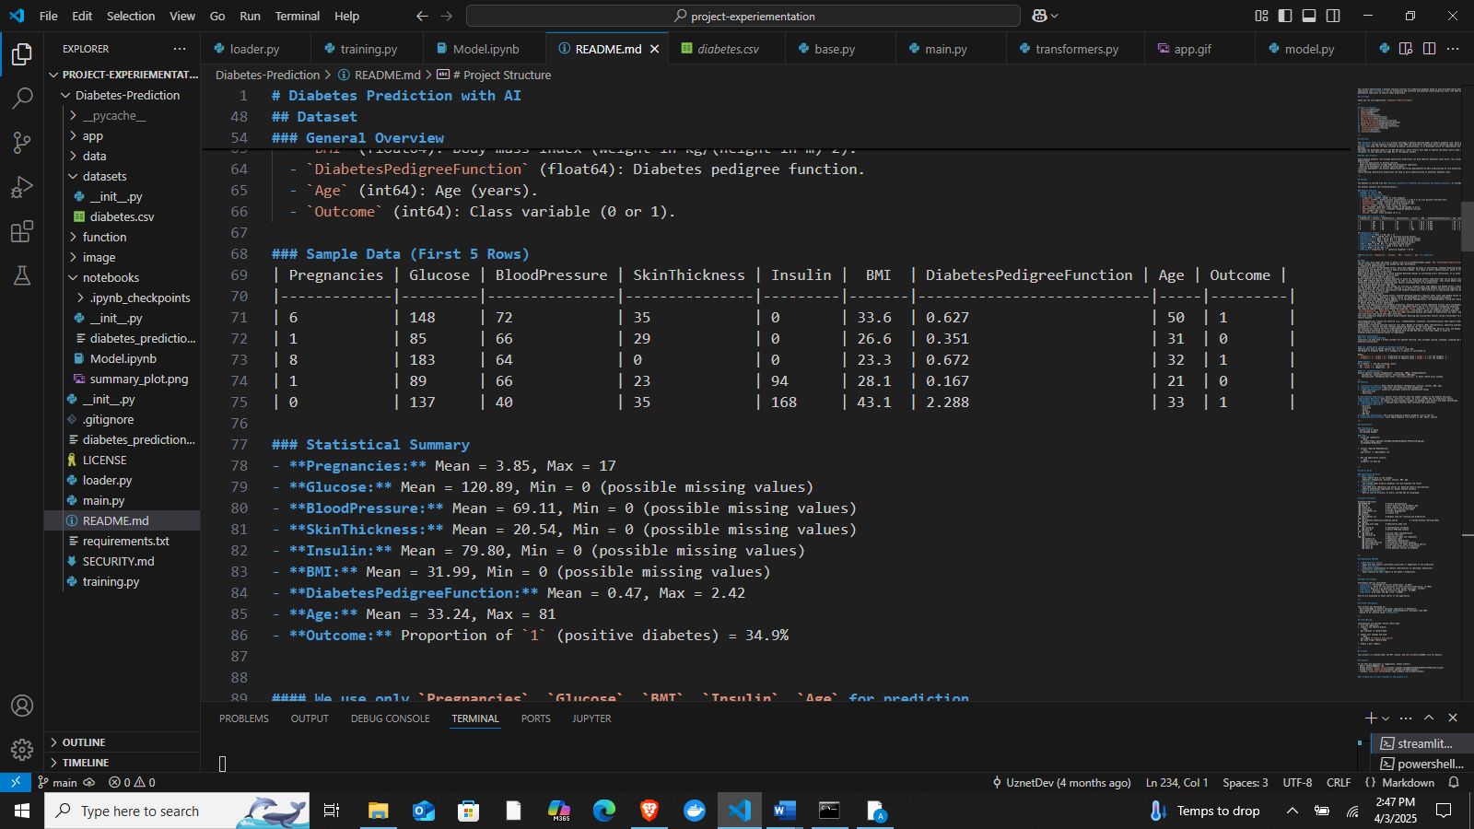

* Glucose Level – Blood glucose concentration
* Blood Pressure – Systolic blood pressure
* Insulin Level – Insulin concentration in the blood
* BMI (Body Mass Index) – Body mass index of the patient
* Age – Age of the patient
* Diabetes Pedigree Function – Genetic predisposition to diabetes
* Outcome – Binary indicator (0 = No diabetes, 1 = Diabetes)

**Appendix B: Machine Learning Models Evaluated**

The following machine learning models were trained and evaluated:

* Logistic Regression
* K-Nearest Neighbors (KNN)
* Support Vector Machine (SVM) (Hyperparameter tuning applied)
* Decision Tree (DT) (Hyperparameter tuning applied)
* Random Forest (RF)
* Gradient Boosting (GBM) *(Selected as the final model)*
* XGBoost

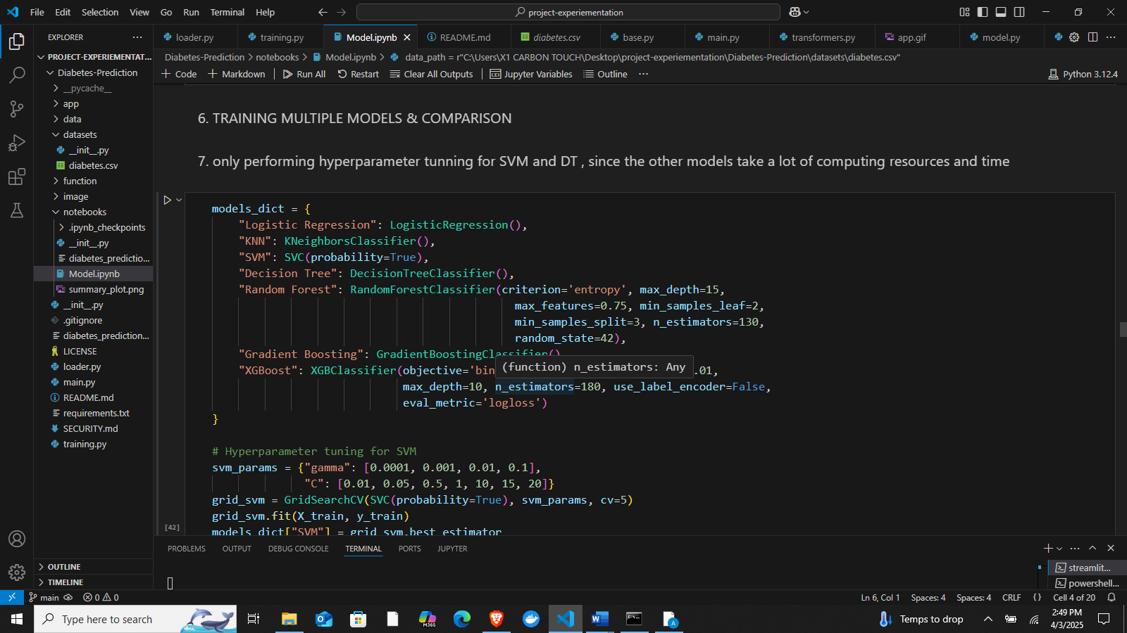

**Appendix C: Model Performance Metrics**

Below are the key performance metrics of the evaluated models:

| Model | Accuracy (%) | Precision | Recall | F1-Score | ROC-AUC (%) |
| --- | --- | --- | --- | --- | --- |
| Logistic Regression | 70.78 | 0.70 | 0.71 | 0.71 | 82.56 |
| K-Nearest Neighbors | 85.06 | 0.85 | 0.85 | 0.85 | 88.34 |
| Support Vector Machine (SVM) | 85.06 | 0.85 | 0.85 | 0.85 | 89.59 |
| Decision Tree | 88.96 | 0.89 | 0.89 | 0.89 | 88.70 |
| Random Forest | 88.31 | 0.88 | 0.88 | 0.88 | 95.01 |
| Gradient Boosting | 87.01 | 0.87 | 0.87 | 0.87 | 95.41 |
| XGBoost | 88.31 | 0.88 | 0.88 | 0.88 | 95.32 |

**Appendix D: Hyperparameter Tuning for SVM and Decision Tree**

Due to computational constraints, hyperparameter tuning was applied only to SVM and Decision Tree:

* Best SVM Parameters: {C: 0.5, gamma: 0.001}
* Best Decision Tree Parameters: {criterion: 'entropy', max\_depth: 10, max\_features: 'log2', min\_samples\_leaf: 5, min\_samples\_split: 3, splitter: 'best'}

**Appendix E: Final Model Selection**

Gradient Boosting was selected as the final model due to its:

* High stability
* Strong classification performance (Accuracy: 87.01%, ROC-AUC: 95.41%)
* Computational efficiency and interpretability

**Appendix F: Implementation Pipeline**

1. Data Preprocessing:
   * Handling missing values
   * Feature scaling and normalization
   * Feature selection based on importance scores

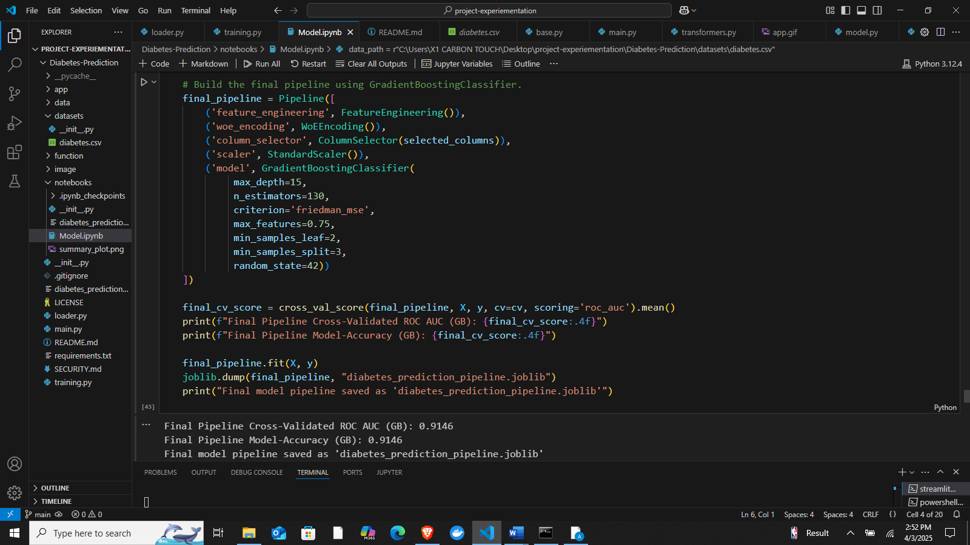

1. **Model Training & Evaluation:**
   * Training models with cross-validation
   * Performance assessment based on accuracy, precision, recall, and F1-score
2. **Deployment**:
   * The best model was integrated into a Streamlit Web Application
   * Enables real-time diabetes risk prediction based on patient input

**Appendix G: Web Application Screenshots**

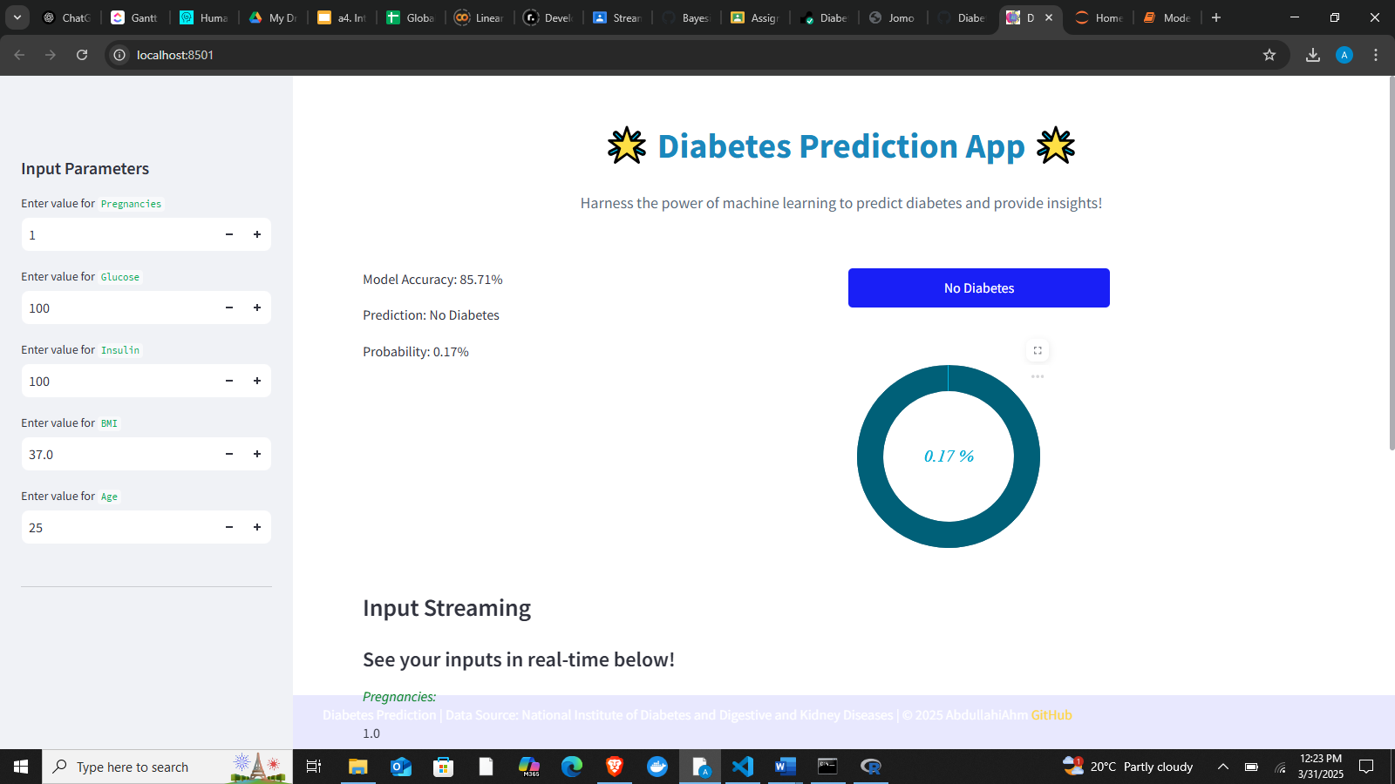

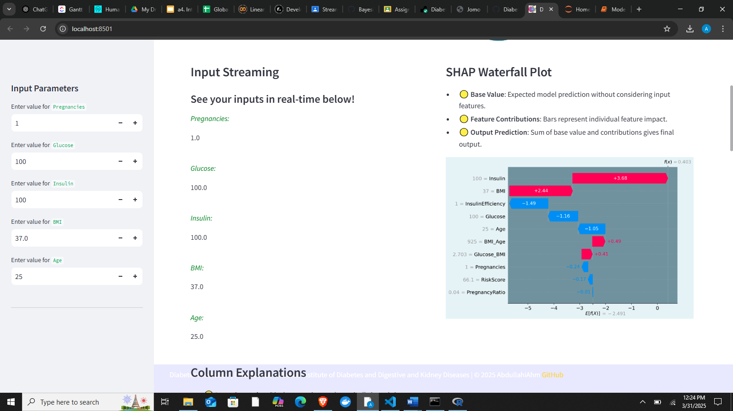

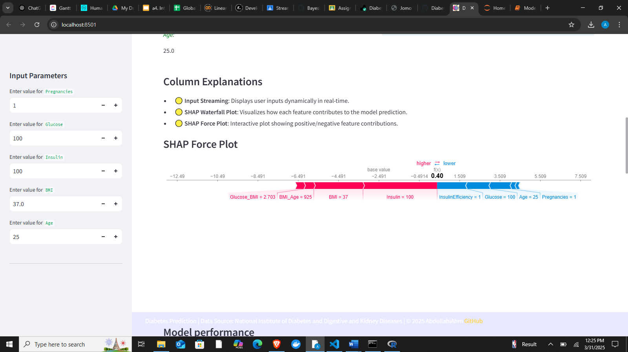

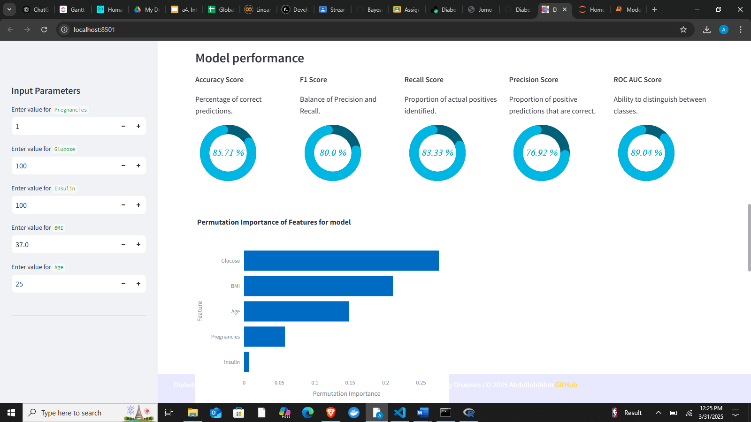



**Appendix H: Source Code and Dependencies**

This section provides detailed information on the programming language, software tools, libraries, and frameworks utilized for the implementation of the **Diabetes Prediction System Using Machine Learning and Streamlit**. The project was developed entirely in Python, leveraging its robust ecosystem for machine learning, data processing, and visualization.

**Programming Language:**

* **Python 3.11**  
  Python was chosen due to its readability, extensive library support, ease of use in machine learning, and active developer community.

**Key Libraries and Dependencies:**

1. **Pandas (v2.2.1)**
   * Used extensively for data manipulation and preprocessing. It facilitated loading datasets, handling missing values, removing duplicates, data normalization, and feature selection.
2. **NumPy (v1.26.4)**
   * Provided support for efficient mathematical computations and array handling, essential for handling structured datasets, matrix operations, and numerical processing during feature engineering and analysis.
3. **Scikit-learn (v1.4.2)**
   * The core library for implementing various machine learning algorithms including:
     + Logistic Regression
     + K-Nearest Neighbors (KNN)
     + Support Vector Machines (SVM)
     + Decision Trees and Random Forest
     + Gradient Boosting Classifier
   * Utilized for model training, hyperparameter tuning (using GridSearchCV), model evaluation metrics (accuracy, precision, recall, F1-score, ROC-AUC), data splitting (train-test-validation), and cross-validation.
4. **XGBoost (v2.0.3)**
   * Implemented as an advanced ensemble machine learning algorithm that showed competitive performance during model evaluation and comparison phases, due to its scalability, robustness, and efficiency in handling structured tabular data.
5. **Streamlit (v1.33.0)**
   * Used for building the user-friendly and interactive web-based application that allows users (patients or healthcare providers) to perform real-time diabetes risk assessments based on user-provided health parameters.
   * Provided interactive user interface elements including sliders, input boxes, buttons, and graphical visualization (charts, graphs, prediction probability displays).
6. **Matplotlib (v3.8.4) & Seaborn (v0.13.2)**
   * These visualization libraries provided intuitive graphical representations of data distributions, model performance metrics, feature importance plots, confusion matrices, ROC-AUC curves, and other diagnostic charts necessary for both exploratory data analysis and final presentation of results.
7. **Altair (v5.3.0)**
   * Additional interactive and dynamic visualizations were created using Altair, enhancing user interaction with the Streamlit application by visualizing prediction probabilities and feature importance dynamically.

**Additional Supporting Libraries:**

* **SHAP (SHapley Additive exPlanations)**
  + Used to interpret the predictions of the Gradient Boosting model, providing insights into the importance and contribution of each feature to the model’s predictions.

**Development and Deployment Environment:**

* **Integrated Development Environments (IDEs):**
  + Jupyter Notebook (for initial exploratory analysis, modeling, hyperparameter tuning)
  + Visual Studio Code (for integration, app development, and deployment)
* **Cloud Platforms:**
  + Google Colab (used for resource-intensive model training, evaluation, and hyperparameter tuning leveraging GPU acceleration)
* **Deployment Environment:**
  + Streamlit Cloud platform was considered for easy, scalable deployment and hosting of the final predictive model web application, ensuring accessibility and scalability.

**Installation of Dependencies:**

All the libraries and dependencies can be easily installed through pip, Python's package installer:

pip install pandas numpy scikit-learn xgboost streamlit matplotlib seaborn altair shap imblearn

**Running the Web Application Locally:**

To run the final predictive web application locally, navigate to the directory containing your Streamlit app (main.py) and run:

streamlit run main.py

The application will launch in your default web browser at:

http://localhost:8501

**Repository and Source Code:**

The full source code, including data preprocessing scripts, trained model files, feature engineering pipelines, and Streamlit application files, has been maintained in a structured repository (such as GitHub) for version control, collaboration, and reproducibility.

**Repository Structure**

Diabetes-Prediction/

├── README.md                 # Project documentation

├── main.py                   # Entry point for the Streamlit app

├── loader.py                 # Data loading and preprocessing

├── training.py               # Script for training the model

├── requirements.txt          # Project dependencies

├── LICENSE                   # License file

├── datasets/

│   ├── diabetes.csv          # Dataset used for training and predictions

├── models/

│   ├── diabetes\_prediction\_pipeline.joblib             # Trained machine learning model

├── images/

│   ├── page\_icon.jpeg        # Application page icon

├── data/

│   ├── config.py             # Configuration variables

│   ├── base.py               # Static HTML/CSS content

├── function/

│   ├── model.py              # Custom model implementation

│   ├── function.py           # Utility functions

└── app/                      # Application logic and components

    ├── predict.py            # Prediction logic

    ├── explainer.py          # SHAP-based explanations

    ├── perm\_importance.py    # Permutation importance analysis

    ├── performance.py        # Visualization of model performance metrics

    ├── input.py              # User input handling for predictions

    ├── about.py              # Informational section on diabetes

**Appendix I: Future Work**

* Integration with electronic health records (EHR) for real-time data analysis
* Development of a mobile-friendly interface for wider accessibility
* Inclusion of real-time patient monitoring features